ALMA Modes for Early Science

ALMA-00.00.00.00-000-A-TTT

Version: A

Status: (Draft)

2004-09-15

Prepared By:
Name(s) and Signature(s) | Organization | Date
Alwyn Wootten | NRAO | 2004-09-15
Approved By:
Name and Signature | Organization | Date
Released By:
Name and Signature | Organization | Date

Change Record

Version | Date | Affected Section(s) | Change Request # | Reason/Initiation/Remarks
A | 2004-09-15 | All | ALMA-00.00.00.00-000-A-CRE | Initiation

Table of Contents

1 Description 4
1.1 Purpose 4
1.2 Scope 4
2 Related Documents and Drawings 4
2.1 References 4
2.2 Abbreviations and Acronyms 4
2.3 Glossary 4
2.4 Related Interface Control Drawings 4

Description

Purpose

With fringes expected around April 2005, the Antenna Test Facility (ATF) Prototype Interferometer offers an excellent opportunity for debugging ALMA modes. However some ATF equipment will not be production ALMA equipment (including the antennas!). Hence, an appealing philosophy for establishing the modes to debug at the ATF is to offer only those modes which can be demonstrated there, augmented by a very few additional modes as final production or preproduction equipment is deployed there. Production equipment will be deployed on the first production antennas in Chile. As closely as possible, the commissioning of the first antennas and interferometer in Chile should follow the path already debugged at the ATF. We explore modes possible for early ALMA tests leading to Early Science under this philosophy.

Scope

xxx

Related Documents and Drawings

References

xxx

Abbreviations and Acronyms

ATF – Antenna Test Facility

Glossary

Mode – a manner, way or method of observing.

Related Interface Control Drawings

Xxx

ALMA Modes

  - Elements of ALMA modes

Elements of an observational setup combine to form a mode. ALMA modes include elements such as Configurations, Receivers, Correlator setups, Calibration strategy and may also include reduction strategy. A description of all modes, or combinations of them, would be difficult. We begin by discussing variations of the elements of ALMA modes.

Configurations

At the ATF, the ALMA configuration is quite simple—a single 30m baseline is available oriented in an East-West direction. This short baseline is minimally sensitive to atmospheric effects. This allows optimal sensitivity for the prototype interferometer to instrumental effects, minimizing sensitivity to atmospheric effects, which may mask the more subtle effects we seek.

In Chile, the ALMA configuration will grow from the first single baseline interferometer, which will reproduce the single 30m baseline established at the ATF. The First Science Array Configurations are defined in ALMA-90.02.00.00-004-A-SPE; they encompass the spacings available from 172 inner pads and assume that six antennas are available for deployment. The antennas may be moved to provide resolution increasing in steps by about a factor of three. Three antennas are moved between configurations. Each of the configurations provides fifteen baselines of which three are shared between sequential configurations. These six configurations provide a wide range of spatial frequencies, which in turn provide spatial dynamic range to the first images ALMA will produce.

The first of these configurations, C1, provides the closest spacings and consequently high brightness temperature sensitivity. However, the range of spatial frequencies measured is small; this array provides poor sidelobes. The second array in the sequence, C2, provides a larger spatial frequency range, beginning with a 15m baseline, and provides better sidelobe characteristics. The beamsize provided is Θ~2.7” at 345 GHz. Subsequent arrays, C3 through C6, increase the resolution to a maximum of Θ~0.033” at 345 GHz. Figure 1 illustrates the antenna positions in the Early Science Array. Table 1 summarizes some properties of these arrays.

Table 1. Properties of the ATF Prototype Interferometer
Frequency (GHz) | Resolution | Beam axial ratio at δ~30˚, 6hr track

95

245

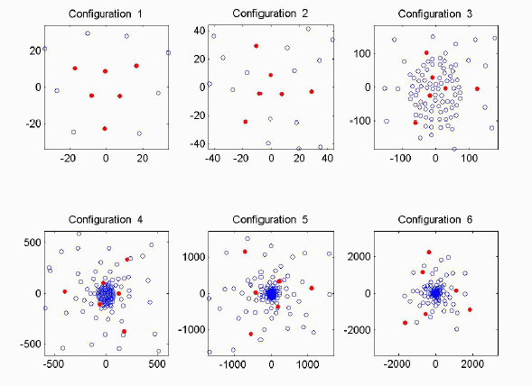

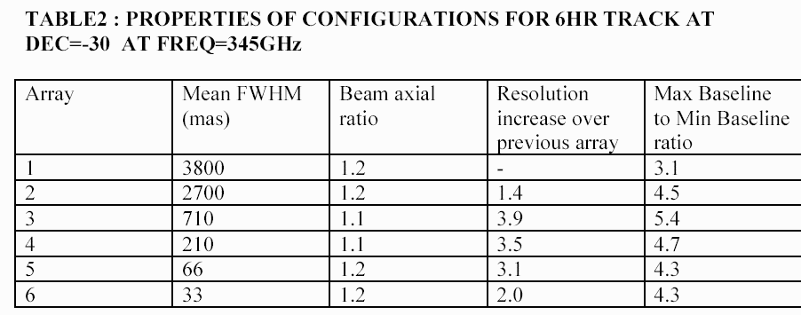

Receivers

ALMA will deploy three types of receivers. The first, not used for astronomical observations, is the holography receiver, which is accompanied by a transmitter. A single receiver was deployed at the ATF, used in the evaluation of the prototype antennas. With slight modifications, this receiver will also be deployed at the OSF for evaluation of the first production antennas. The transmitter deployed at the ATF apparently no longer exists; a suitable replacement will be needed at the OSF.
Band | Start Frequency | Stop Frequency | Remarks

3mm

1.3mm
Table 3

Evaluation receiver properties.

The second type of receiver includes those several frequency bands used for normal astronomical observations. At the ATF, the atmosphere allows operation only rarely at frequencies above 270 GHz, the highest frequency reached by the evaluation receiver. Properties of the evaluation receivers are tabulated in Table 3. These receivers will not be deployed to Chile, but provide the receiver elements of modes available at the ATF during its early operation. As the preproduction receivers become available, they will be deployed to the ATF to replace the evaluation receivers; properties of these receivers (from ALMA-40.00.00.00-015-A-SPE) are given in Table 4. It is expected that at least one receiver will be available for B3 and B6 by the end of the period of operation of the ATF interferometer. Only preproduction receivers will be available in Chile during the period ending with Early Science.
Band | Start frequency | Stop frequency | Remarks
1 | 31.3 GHz | 45 GHz
2 | 67 GHz | 90 GHz
3 | 86 GHz | 116 GHz | operation to 84 GHz
4 | 125 GHz | 163 GHz
5 | 163 GHz | 211 GHz
6 | 211 GHz | 275 GHz
7 | 275 GHz | 370 GHz | operation to 373 GHz
8 | 385 GHz | 500 GHz
9 | 602 GHz | 720 GHz
10 | 787 GHz | 950 GHz

Table 4

Specifications and requirements do not apply for operation outside nominal frequency limits.

The ALMA water vapor radiometer (WVR) is the third type of ALMA receiver. Depending upon the outcome of the selection review, WBS4.210.1011 calls for delivery either to the ATF or to the OSF. We expect that these will be deployed at the ATF for system testing; production units will be deployed on the ALMA antennas in Chile. Specifications for the WVR are given in FEND-40.07.00.00-001-A-SPE.

Any combination of available ALMA receiver elements constitutes the receiver element of an ALMA mode.

Correlator

A prototype correlator will be deployed at the ATF site for the single baseline prototype interferometer. A subset of the modes which will be available on the final ALMA correlator will be provided on the prototype correlator. Following the philosophy given in 1.1, these modes will be provided on the ALMA correlator for Early Science in Chile. In time, these modes will be expanded.

Modes available for the prototype correlator are listed in Table 5.
Bandwidth | Single Polarization | Dual Polarization | Full Polarization
2 GHz | 256 | 128 | 64
128 MHz | 2048 | 1024 | 512
31.25 MHz | 8192 | 4096 | 2048
Table 5

Modes available in the ALMA prototype correlator, two bit correlation.

Calibration Strategies

The full panoply of ALMA calibration strategies will be deployed gradually as ALMA is constructed. Some will be available at the ATF, others will be available for Early Science and a few await fuller deployment of ALMA instrumentation.

Phase Correction

Use of the WVRs for phase correction should be useful for some of the more extended baselines at the ALMA site; their use will be marginal at the ATF owing to the single short baseline. Normally, the WVRs will be employed with other techniques, such as fast switching, to provide the optimal degree of phase correction.

Pointing Calibration

Amplitude and Flux Calibration

Tests of feasibility of ALMA amplitude calibration devices continue at the time of writing. Currently at the ATF a rotating hot load of ‘bow tie’ design is synchronously detected to provide amplitude calibration of the evaluation receivers. In this device, microwave absorber at ambient temperature is mounted on two quarters of the area of a rotating disk on opposite sides. The intervening quarters are cut away, allowing observation of the sky. One variety of amplitude calibration device constructed and partially tested incorporates a semitransparent material so that the signal presented to the receiver is well-matched to that presented by the sky, minimizing saturation effects in the receiver. Tests of this device in the receiver room of the IRAM 30m telescope showed inconsistent results; tests on the actual sky were not obtained. Further tests are underway in a laboratory in Madrid, at a frequency of 60 GHz. Tests on the sky at the actual ALMA operating frequencies would be desirable and could be executed at the ATF. A simple modification of this design could mount semitransparent material on the cutaway quarters. This is an ALMA amplitude calibration mode which would not be implemented beyond the ATF.

An amplitude calibration device incorporating semitransparent loads similar to that tested at IRAM could be employed on ALMA. If implemented, this system would be integrated into the ALMA antenna above the cryostat and might be tested at the ATF before deployment in Chile.

In ALMA Memo No. 461, Bacmann and Guilloteau proposed a multiload system. The feasibility of this system is currently under study. If implemented, this system would be integrated into the ALMA antenna above the cryostat and might be tested at the ATF before deployment in Chile.

Bandpass Calibration

A bandpass calibration element

Optics Calibration

Antenna and Electronic Delay Calibration

Antenna Location Calibration

Polarization Calibration

Total Power

Examples—DRSP Projects which may be executed with Early Science Modes

