Pad Numbers and Locations
for the Inner 172 Pads

ALMA-00.00.00.00-000-A-SPE

Version: A

Status: Draftt

2002-12-11
Prepared By:
Name(s) and Signature(s) | Organization | Date
John Conway | Onsala Space Observatory | 2002-11-25
Approved By:
Name and Signature | Organization | Date
Xxx  xxx | Xxx  Xxx | yyyy-mm-dd  yyyy-mm-dd
Released By:
Name and Signature | Organization | Date
xxx | Xxx | yyyy-mm-dd

Change Record

Version | Date | Affected Section(s) | Change Request # | Reason/Initiation/Remarks
A | yyyy-mm-dd | xxxxx | ALMA-00.00.00.00-000-A-CRE | xxxxxxx

Table of Contents

1 Introduction 0
2 Pad Numbers and Positions 0
2.1 Relative pad Positions for Surveying 0
2.2 Horizontal Positions Tolerances 0
2.3 Vertical Position Tolerances 0

Introduction
This specification document gives the pad numbers and positions for the first 172 pads of baseline ALMA. The pads specified in this document will be used for configurations of ALMA with maximum baselines out to 4km. An additional number of pads (approximately 42) will be needed for the larger configurations. The positions and numbering of these pads will be presented in a future specifications document. The pads described in the document refer only to the requirements of baseline ALMA (joint US-Europe project). If there is future Japanese participation additional pads for both 12m diameter and smaller diameter antennas may be specified, these specifications are beyond the scope of this document.
Section 2 describes the pad numbers and positions. Sections 2.1 defines the monument which defines the coordinate system and then gives the relative pad positions. Section 2.2 describes the horizontal tolerances on the pad positions. Section 2.3 specifies the vertical tolerances of the pad positions.

Pad Numbers and Positions

Relative pad Positions for Surveying
Tables 1 to 5 give pad positions relative to the array center point, and the positions of the array center point is defined relative to the monument ‘Master 0’. This monument is approximately 50m East of the NRAO container. The array center relative to this monument is defined to be:

720.4m SOUTH and 39.5m WEST of ‘Master 0’.

The positions of ‘Master 0’ has been measured by differential GPS in the PSAm56 datum and were found to be:

Master 0: E = 627829.73 m; N = 7453791.35 m

This monument has been chosen to define the surveying at the site because it is visible in high resolution aerial photography. The pad positions have been fitted to digital elevation models derived from this photography. To ensure that there is no ambiguity in placing the pads relative to terrain features the pad positions given in Tables 1 to 5 are referenced directly to the above monument rather than given in absolute coordinates.

Horizontal Position Tolerances
Tables 1 to 5 give two tolerances for the horizontal position of a pad relative to the centre. The astronomical performance depends on the relative pad positions, and these tolerances reflect the size of shifts in pad positions which will start to effect astronomical performance. Any pad can be moved up to a distance of ‘Tolerance 1’ without any significant effect on performance. Tolerance 1 therefore indicates the size of the required construction tolerance. The larger Tolerance 2 indicates the maximum distance any pad should be moved from its nominal position in order to avoid terrain obstacles. Only a limited number of pads should be moved this distance. The different pads are allocated ‘Radius groups’ depending on their distance from the centre of the array. It is recommended that no more than 5 pads in any radius group be displaced by amounts between ‘Tolerance 1’ and ‘Tolerance 2’. Changes exceeding these guidelines should be referred back to the Configuration group of the Science IPT for confirmation. For pads in some radius groups the two tolerances are set equal to each other; in this case all antennas in this radius group can be moved up to the defined tolerance.
For pads in the compact array (pad numbers 1 to 68) the horizontal tolerance is set to 1 cm. This reflects the requirement of transporter access and the requirement for no mechanical interference between antennas (set to the requirement that no two antennas approach closer than 15m). The astronomical requirement is for a tolerance of 10 cm for this group. Relaxing the present 1 cm figure given in Tables 1 to 4 requires interaction between the site and antenna IPTs. As long as the tolerance is better than 10 cm then there are no constraints from the Science IPT.
There are 9 pads that are in lettered Radius Groups A, B, C. Group A consists of pads 115, 123, 170. Group B of pads 114, 122, 171 and Group C pads of pads 124, 132, 172. The relative positions of pads in each lettered group are critical, all pads within a group must keep the same relative position. If a shift is applied to one pad in such a group it must be applied to all. The allowed maximum shift is given in the Tolerance 1 and 2 columns.

Vertical Position Tolerances
Astronomical considerations require that pads 1 to 68 should not differ in height from an inclined plane by more than +/-0.4 m.. The inclined plane should not have a gradient of more than 2%. Transporter access requirements on the heights of antennas within the compact group may be more stringent than these limits but are beyond the scope of this document. There is no specification on the heights of any other pads.

Table 1: Pad Number and Locations Relative to Array Centre
Pad Number | Radius Group | Position East of centre (m) | Position North of centre (m) | Tolerance 1 (m) | Tolerance 2 (m)
1 | 1 | -0.41 | 8.64 | 0.01 | 0.01
2 | 1 | 16.29 | 11.61 | 0.01 | 0.01
3 | 1 | 11.11 | 27.75 | 0.01 | 0.01
4 | 1 | 28.29 | -3.06 | 0.01 | 0.01
5 | 1 | 58.38 | -22.38 | 0.01 | 0.01
6 | 1 | 53.75 | -2.88 | 0.01 | 0.01
7 | 1 | 48.96 | 19.4 | 0.01 | 0.01
8 | 1 | 43.02 | 33.79 | 0.01 | 0.01
9 | 1 | 23.77 | 56.26 | 0.01 | 0.01
10 | 1 | 12.75 | 68.36 | 0.01 | 0.01
11 | 1 | 72.88 | -33.42 | 0.01 | 0.01
12 | 1 | 71.93 | -15.44 | 0.01 | 0.01
13 | 1 | 68.59 | 0.31 | 0.01 | 0.01
14 | 1 | 64.26 | 22.38 | 0.01 | 0.01
15 | 1 | 33.79 | 18.83 | 0.01 | 0.01
16 | 1 | 50.19 | 47.09 | 0.01 | 0.01
17 | 1 | 44.22 | 60.97 | 0.01 | 0.01
18 | 1 | 25.37 | 77.62 | 0.01 | 0.01
19 | 1 | 13.13 | 86.4 | 0.01 | 0.01
20 | 1 | 26 | 41.22 | 0.01 | 0.01
21 | 1 | -7.95 | -4.47 | 0.01 | 0.01
22 | 1 | -16.8 | 10.21 | 0.01 | 0.01
23 | 1 | -26.66 | -1.78 | 0.01 | 0.01
24 | 1 | -10.07 | 29.29 | 0.01 | 0.01
25 | 1 | -9.88 | 68.51 | 0.01 | 0.01
26 | 1 | -26.11 | 52.32 | 0.01 | 0.01
27 | 1 | -40.04 | 35.99 | 0.01 | 0.01
28 | 1 | -50.17 | 19.23 | 0.01 | 0.01
29 | 1 | -52.83 | -9.35 | 0.01 | 0.01
30 | 1 | -59.45 | -23.61 | 0.01 | 0.01
31 | 1 | -9.73 | 83.8 | 0.01 | 0.01
32 | 1 | -23.12 | 76.96 | 0.01 | 0.01
33 | 1 | -36.23 | 64.93 | 0.01 | 0.01
34 | 1 | -51.66 | 47.46 | 0.01 | 0.01
35 | 1 | -33.34 | 20.86 | 0.01 | 0.01
36 | 1 | -64.65 | 26.88 | 0.01 | 0.01
37 | 1 | -69.74 | 2.88 | 0.01 | 0.01
38 | 1 | -74.11 | -18.77 | 0.01 | 0.01
39 | 1 | -74.39 | -34.07 | 0.01 | 0.01
40 | 1 | -43.04 | 2.38 | 0.01 | 0.01

Table 2: Pad Number and Locations Relative to Array Centre

Pad Number | Radius Group | Position East of centre (m) | Position North of centre (m) | Tolerance 1 (m) | Tolerance 2 (m)
41 | 1 | 7.3 | -4.76 | 0.01 | 0.01
42 | 1 | -0.85 | -22.42 | 0.01 | 0.01
43 | 1 | 17.8 | -25.01 | 0.01 | 0.01
44 | 1 | -17.69 | -24.37 | 0.01 | 0.01
45 | 1 | -45.37 | -43.48 | 0.01 | 0.01
46 | 1 | -31.1 | -49.34 | 0.01 | 0.01
47 | 1 | -9.83 | -55.68 | 0.01 | 0.01
48 | 1 | 8.63 | -56.62 | 0.01 | 0.01
49 | 1 | 34.58 | -42.25 | 0.01 | 0.01
50 | 1 | 49.73 | -43.82 | 0.01 | 0.01
51 | 1 | -60.71 | -51.75 | 0.01 | 0.01
52 | 1 | -47.25 | -58.55 | 0.01 | 0.01
53 | 1 | -30.78 | -64.61 | 0.01 | 0.01
54 | 1 | -12.51 | -70.6 | 0.01 | 0.01
55 | 1 | -2.13 | -39.39 | 0.01 | 0.01
56 | 1 | 14.51 | -73.58 | 0.01 | 0.01
57 | 1 | 30.33 | -68.6 | 0.01 | 0.01
58 | 1 | 48.3 | -60.23 | 0.01 | 0.01
59 | 1 | 62.56 | -53.5 | 0.01 | 0.01
60 | 1 | 19.53 | -43.28 | 0.01 | 0.01
61 | 1 | -59.32 | -82.47 | 0.01 | 0.01
62 | 1 | -44.42 | -84.96 | 0.01 | 0.01
63 | 1 | -28.87 | -89.73 | 0.01 | 0.01
64 | 1 | -12.83 | -95.51 | 0.01 | 0.01
65 | 1 | 12.21 | -95.92 | 0.01 | 0.01
66 | 1 | 30.03 | -95.15 | 0.01 | 0.01
67 | 1 | 44.22 | -89.78 | 0.01 | 0.01
68 | 1 | 59.96 | -84.46 | 0.01 | 0.01
69 | 1 | -29.86 | -114.82 | 0.1 | 0.1
70 | 1 | -12.94 | -118.65 | 0.1 | 0.1
71 | 1 | 14.5 | -119.39 | 0.1 | 0.1
72 | 1 | 36.45 | -114.65 | 0.1 | 0.1
73 | 1 | 58.61 | 65.83 | 0.1 | 0.1
74 | 1 | -76.01 | 36.89 | 0.1 | 0.1
75 | 1 | 28.38 | 102.4 | 0.1 | 0.1
76 | 1 | -113.99 | -3.79 | 0.1 | 0.1
77 | 1 | -27.99 | 103.51 | 0.1 | 0.1
78 | 1 | -60.5 | -105.84 | 0.1 | 0.1
Table 3: Pad Number and Locations Relative to Array Centre

Pad Number | Radius Group | Position East of centre (m) | Position North of centre (m) | Tolerance 1 (m) | Tolerance 2 (m)
79 | 2 | 123.5 | -4.2 | 1.2 | 6.2
80 | 2 | -94.9 | 77 | 1.2 | 6.1
81 | 2 | -12.9 | -143 | 1.4 | 7.2
82 | 2 | 96.9 | 79.9 | 1.3 | 6.3
83 | 2 | -152.3 | -3.1 | 1.5 | 7.6
84 | 2 | 49.3 | -125.6 | 1.3 | 6.7
85 | 2 | 60 | 129 | 1.4 | 7.1
86 | 2 | -146.1 | -101.3 | 1.8 | 8.9
87 | 2 | 146.3 | -60.2 | 1.6 | 7.9
88 | 2 | -9.1 | 151.2 | 1.5 | 7.6
89 | 2 | -46.6 | -151.3 | 1.6 | 7.9
90 | 2 | 147.8 | 64.6 | 1.6 | 8.1
91 | 2 | -123 | 143.1 | 1.9 | 9.4
92 | 2 | 55 | -185.2 | 1.9 | 9.7
93 | 2 | 118.1 | 142.5 | 1.9 | 9.3
94 | 2 | -186.6 | 38.5 | 1.9 | 9.5
95 | 2 | 167.7 | -122.3 | 2.1 | 10.4
96 | 2 | 36.5 | 212.7 | 2.2 | 10.8
97 | 2 | -215.4 | -70.9 | 2.3 | 11.3
98 | 2 | 225.3 | 25.8 | 2.3 | 11.3
99 | 2 | -103.1 | 211.7 | 2.4 | 11.8
100 | 2 | -100.2 | -240.5 | 2.6 | 13
101 | 2 | 175.8 | 147.1 | 2.3 | 11.5
102 | 3 | -247 | 111 | 3 | 14
103 | 3 | 19 | -257 | 3 | 13
104 | 3 | 105 | 286 | 3 | 15
105 | 3 | -298 | -51 | 3 | 15
106 | 3 | 152 | -276 | 3 | 16
107 | 3 | -53 | 301 | 3 | 15
108 | 3 | -231 | -181 | 3 | 15
109 | 3 | 226 | -33 | 2 | 11
110 | 3 | -276 | 193 | 3 | 17
111 | 3 | -9 | -404 | 4 | 20
112 | 3 | 218 | 159 | 3 | 13
113 | 3 | -406 | 16 | 4 | 20
114 | B | 177 | -374 | 20 | 20
115 | A | 205 | 331 | 20 | 20
116 | 3 | -390 | -193 | 4 | 22
117 | 3 | 432 | -87 | 4 | 22
Table 4: Pad Number and Locations Relative to Array Centre
Pad Number | Radius Group | Position East of centre (m) | Position North of centre (m) | Tolerance 1 (m) | Tolerance 2 (m)
118 | 3 | 28 | 444 | 4 | 22
119 | 3 | -143 | -502 | 5 | 26
120 | 3 | 411 | 125 | 4 | 21
121 | 3 | -278 | 443 | 5 | 26
122 | B | 129 | -543 | 20 | 20
123 | A | 356 | 366 | 20 | 20
124 | C | -548 | 220 | 20 | 20
125 | 4 | 478 | -401 | 6 | 31
126 | 4 | 119 | 627 | 6 | 32
127 | 4 | -599 | -145 | 6 | 31
128 | 4 | 616 | -27 | 6 | 31
129 | 4 | -269 | 587 | 6 | 32
130 | 4 | -423 | -535 | 7 | 34
131 | 4 | 446 | 474 | 7 | 33
132 | C | -618 | 359 | 20 | 20
133 | 4 | 5 | -687 | 7 | 34
134 | 4 | 262 | 739 | 8 | 39
135 | 4 | -786 | 11 | 8 | 39
136 | 4 | 516 | -566 | 8 | 38
137 | 4 | -184 | 1064 | 11 | 54
138 | 4 | -674 | -507 | 8 | 42
139 | 4 | 758 | -215 | 8 | 39
140 | 4 | -439 | 407 | 6 | 30
141 | 4 | -193 | -991 | 10 | 50
142 | 4 | 847 | 312 | 9 | 45
143 | 4 | -1006 | 128 | 10 | 51
144 | 4 | 956 | -590 | 11 | 56
145 | 4 | 584 | 995 | 12 | 58
146 | 4 | -873 | -686 | 11 | 56
147 | 5 | 878 | -934 | 13 | 64
148 | 5 | -1 | 1299 | 13 | 65
149 | 5 | -544 | -1123 | 12 | 62
150 | 5 | 1103 | 139 | 11 | 56
151 | 5 | -707 | 1142 | 13 | 67
152 | 5 | 450 | -972 | 11 | 54
153 | 5 | 921 | 1101 | 14 | 72
154 | 5 | -1246 | 113 | 13 | 63
155 | 5 | 1151 | -1078 | 16 | 79
156 | 5 | 301 | 1811 | 18 | 92
157 | 5 | -1398 | -423 | 15 | 73
Table 5: Pad Number and Locations Relative to Array Centre

Pad Number | Radius Group | Position East of centre (m) | Position North of centre (m) | Tolerance 1 (m) | Tolerance 2 (m)
158 | 5 | 1595 | -32 | 16 | 80
159 | 5 | -634 | 1502 | 16 | 82
160 | 5 | -1021 | -1560 | 19 | 93
161 | 5 | 1583 | 1096 | 19 | 96
162 | 5 | -1214 | 1112 | 16 | 82
163 | 5 | -289 | -1283 | 13 | 66
164 | 5 | 688 | 1951 | 21 | 103
165 | 5 | -1691 | -139 | 17 | 85
166 | 5 | 1131 | -1943 | 22 | 112
167 | 5 | -365 | 2246 | 23 | 114
168 | 5 | -1676 | -1611 | 23 | 116
169 | 5 | 1837 | -883 | 20 | 102
170 | A | 240 | 343 | 20 | 20
171 | B | 168 | -409 | 20 | 20
172 | C | -558 | 249 | 20 | 20

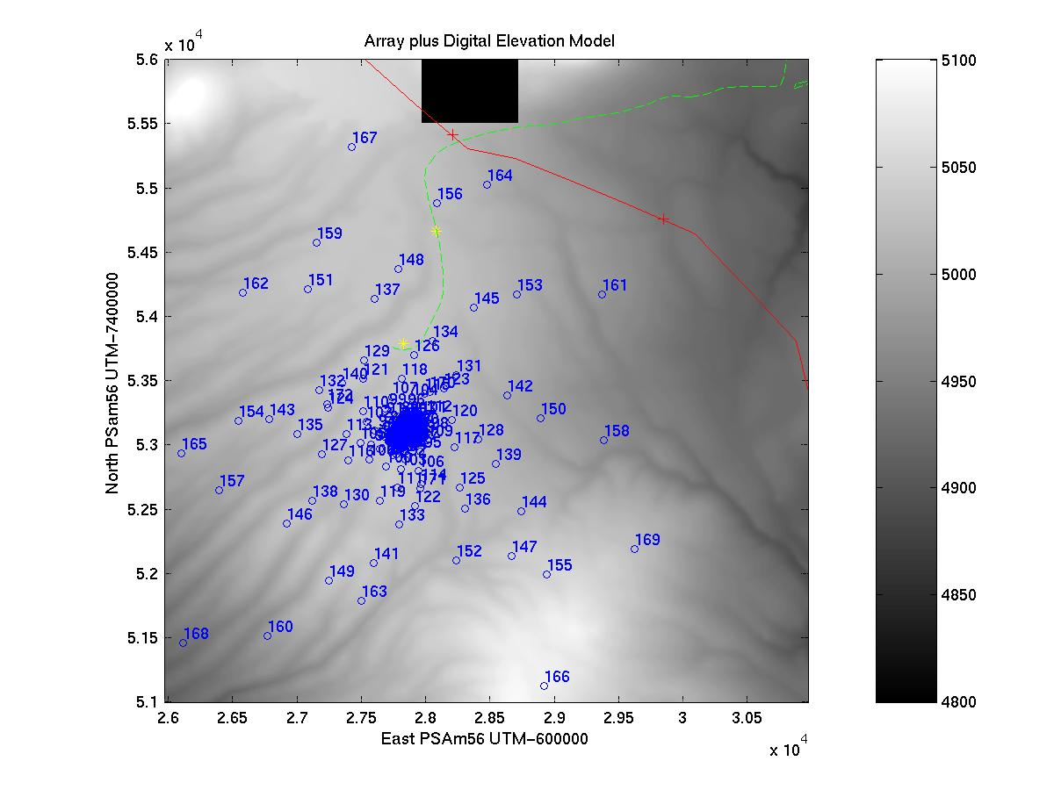

Figure 1: The pad positions overlaid on a grayscale showing Elevation (Black 4800m – White 5100m). The two yellow stars indicate the monuments ‘Master 0’ and ‘Master 71’. The green dotted line is the existing unpaved access road to the site from the Jama highway. The red line is the gas pipeline and the red crosses indicate the positions of reinforced crossing points.

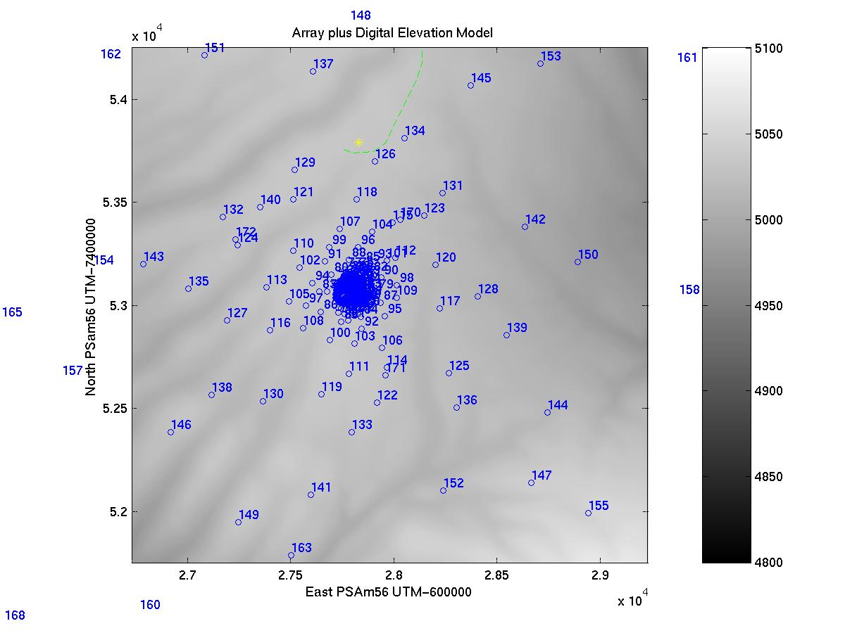

Figure 2: Zoom of the outer intermediate pads. Grayscale is elevation.

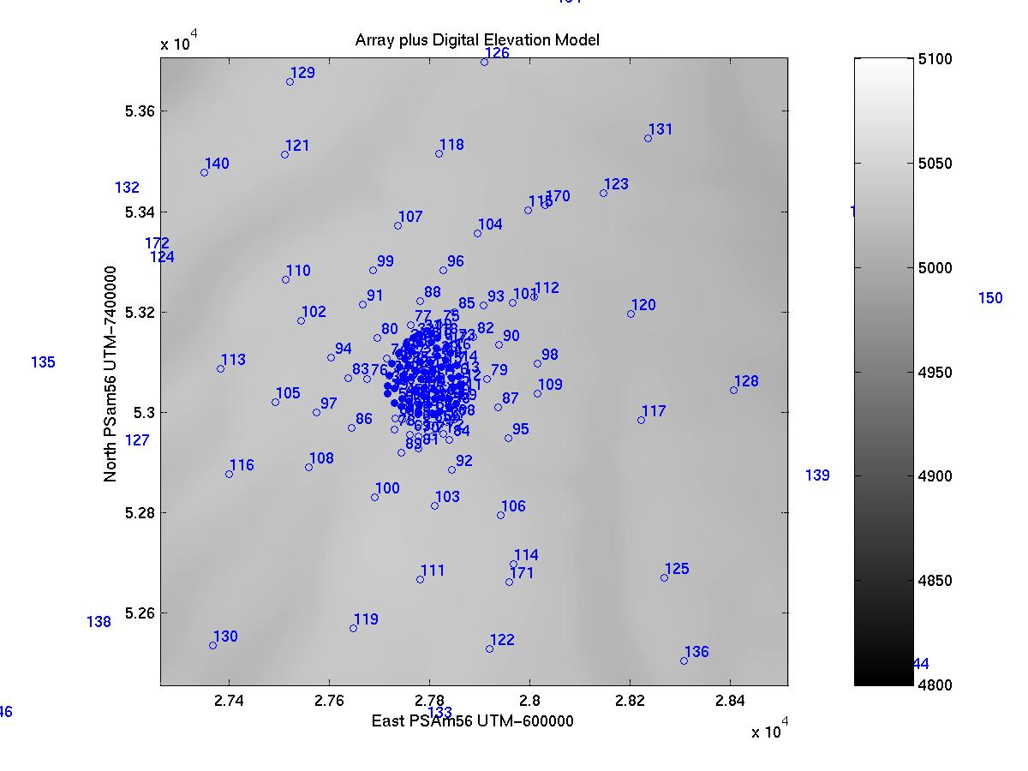

Figure 3: Zoom of the inner intermediate pads. Grayscale is elevation.

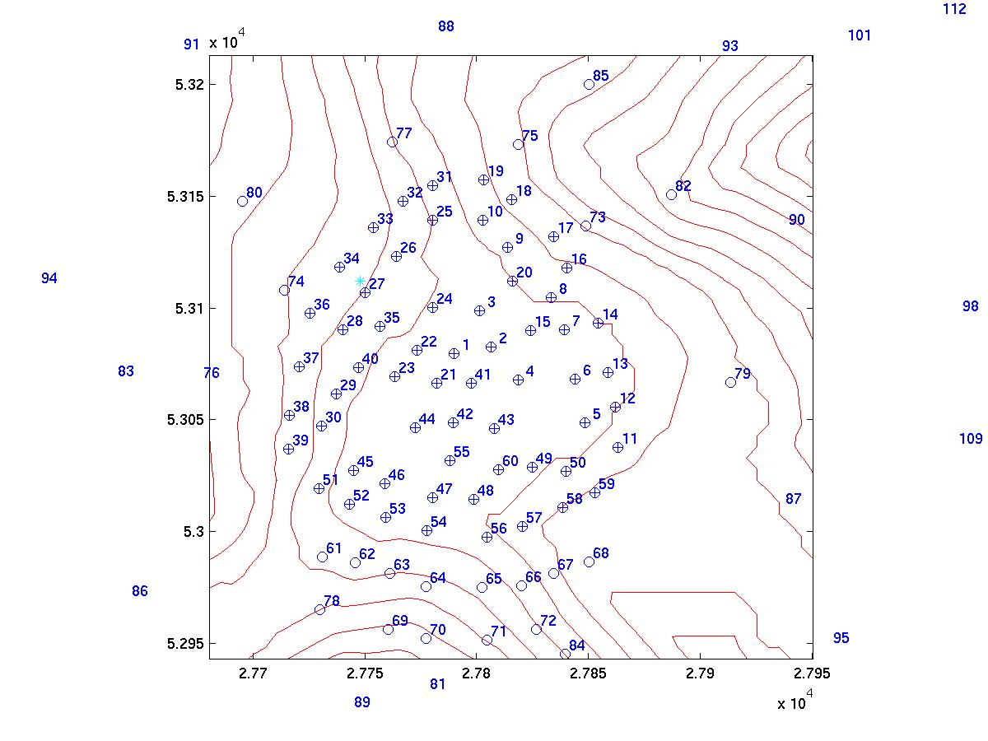

Figure 4: The central part of the array. Contours are set at 0.5 m intervals
and have been re-interpolated from the Digital Elevation Model.. The
Cyan colored star is the position of ‘Chajnantor South’ as defined
in ALMA memo 338.

