Procedure for Calculating and Collecting PAI Data for Beam Patterns

ALMA-40.00.00.00-123-A-PRO

Version: A01
Status: Draft

2008-03-10

Prepared By: | Organization | Date
Josh Crabtree | NRAO | 2008-03-10
Approvals: | Organization | Date

Change Record

Version | Date | Affected Section(s) | Change Request # | Reason/Initiation/Remarks
A01 | 2008-03-07 | All | - | First draft
A02 | 2008-03-10 | 6.3 |  | Modified to reflect that beam efficiency and phase unwrapping are now performed by the same application.

Table of Contents

1. Scope 8
1.1. Identification 8
1.2. System overview 8
1.3. Document overview 8
1.4. Acronyms and abbreviations 8
2. Referenced documents 8
2.1. Applicable documents 8
2.2. Reference documents 8
3. Required Data 8
3.1. All Beam Scans 9
3.2. Co-Polar Beam Scans 9
3.3. Cross-Polar Beam Scans 9
4. Beam Scan Setup 9
5. Gathering data for all beam scans 11
-Frequency Used For Scan 11
-Elevation (Tilt) Angle 11
-Whether the scan is Co-Polar or Cross-Polar 11
-Whether the scan is for Pol 0 or Pol 1 11
-IF attenuation (dB) used during scan 11
6. Gathering data for Co-Polar beam scans 11
6.1. Listings and Images (Script-driven Procedure) 11
6.1.1. Listings and Images (Script-driven Procedure) 11
6.1.1.1. Opening and starting the program 11
6.1.1.2. Select an NSI data file 12
6.1.1.3. Find the optimal XYZ shift amounts 12
6.1.2. Find the optimal Z shift amount 13
6.1.3. Find the optimal X and Y shift amounts 14
6.1.4. Export Listings and Images 16
6.2. Listings and Images (Manual Procedure) 17
6.2.1. Maximum global far field amplitude (dB) 17
6.2.2. Maximum global near field amplitude (dB) 18
6.2.3. Shift amounts (m) applied to the far field transform in the X, Y, and Z directions 19
6.2.4. Hcut (azimuth) and Vcut (elevation) cut images for far field amplitude and phase across subreflector. 23
6.2.5. Far field amplitude and phase images 24
6.3. Image of phase on subreflector 27
6.3.1. Calculate beam center coordinates 27
6.3.2. Plot Phase Map 29
6.3.3. If necessary, unwrap phase 30
6.3.3.1. Simple Unwrap Full Map 31
6.3.3.2. Unwrap 32
6.3.3.2.1. Selecting a center point 32
6.3.3.2.2. Selecting a radius 33
6.3.3.2.2.1. First Radius Option 34
6.3.3.2.2.2. Second Radius Option 34
6.3.3.2.2.3. Third Radius Option 35
6.3.3.2.2.4. Fourth Radius Option 35
6.3.3.2.2.5. Fifth Radius Option 35
6.3.3.2.2.6. Sixth Radius Option 35
6.3.3.2.3. Number of Iterations 36
6.3.3.2.4. Unwrap Button 36
6.3.3.2.5. Specific Approaches to Phase Unwrapping 36
6.3.3.2.5.1. Approach 1- Simple Unwrap, then Unwrap 36
6.3.3.2.5.2. Approach 2- Use 360 deg, then 180 deg discontinuity value 37
6.3.3.2.5.3. Approach 3- Try different center points and/or radii 37
6.3.3.2.5.4. Approach 4- Find a “Peak Phase Point” through visual inspection 37
6.3.3.2.5.5. Approach 5- Manually adjust points in a 2-d phase map 41
6.3.3.2.6. Notes about phase unwrapping 45
6.3.4. Get Image of Phase Map 45
6.4. Beam Efficiency Data 45
6.4.1. Open “Beam Efficiency Calculator.xls” 45
6.4.2. Select Band Number 45
6.4.3. Press “Get Center Values” button 45
6.4.4. Press “Get Beam Efficiencies” button 46
6.5. Beam center coordinates for near field and hologram 46
6.6. Plot picture of far field beam center points 47
6.6.1. Open “Draw Circles and Points.vi” in LabView. 47
6.6.2. Determine number of points being plotted 47
6.6.3. Modify block diagram to accommodate the appropriate number of points 47
6.6.4. Enter beam center coordinates at front panel 49
6.6.5. Plot the values 50
6.6.6. Put the appropriate names in the plot legend 51
6.6.7. Use the same color for all scans at the same frequency 51
6.6.8. Use circle point style for Pol 0, and square point style for Pol 1 51
6.6.9. Use hollow point style for Tilt Angle of 0, solid point style for tilt angle of 45. 51
7. Gathering Data for cross-polar beam scans 51
7.1. Far field amplitude image 52
8. Putting the data together 52
8.1. Open the “Collected Data.xls” spreadsheet 52
8.2. Create a sheet for each beam scan 52
8.3. Enter the settings for each beam scan on each sheet 53
8.4. If Co-Polar, Copy and paste the beam efficiency data into the sheet 53
8.5. If Co-Polar, Enter the Maximum Global Amplitude and IF Attenuation values for the Far field and near field listings 54
8.6. If Cross-Polar, Enter the Maximum Global Amplitude and IF Attenuation values for the Far field listing 55
8.7. If Co-Polar, enter the center values for the near field and hologram listings 55
8.8. If Co-Polar, enter the XYZ shift amounts 55
8.9. If Co-Polar, copy and paste the following images into the sheet: 56
8.10. Enter the appropriate azimuth and elevation values for the nominal beam center at the top of the main page 56
8.11. Press the “Populate Cells” button on the main page 56
8.12. Copy and past the picture of the Beam Center plot on the main page 57
8.13. Important notes regarding the Collected Data sheet 58
A. Appendix A- “Main Beam Scan Program.bas” 59
B. Appendix B- “Listings and Images.bas” 64
C. Appendix C- Nominal Beam Center Coordinates 71

List of Figures
Figure 1- Beam Scan Setup dialog 10
Figure 2- Beam Scan Notes File 10
Figure 3- Opening a Script in NSI2000 12
Figure 4- XYZ Shift Amounts Dialog Window 13
Figure 5- Effect of Z Shift on Phase 14
Figure 6- Phase Cut Across Entire Far field 15
Figure 7- Phase Cut Across Subreflector 15
Figure 8- XYZ Shift Dialog finished 16
Figure 9- Settings for Exported Listings and Images Dialog 16
Figure 10- File Names Displayed in NSI2000 Debug Window 17
Figure 11- Max Global Amplitude in Far Field text file 17
Figure 12- Simple script to create and save Far Field listing 18
Figure 13- Max Global Amplitude in Near Field text file 18
Figure 14- Far Field Button 19
Figure 15- Far field Display Dialog 19
Figure 16- Far Field Transform Setup Dialog 20
Figure 17- Far field Plot Parameters Dialog 20
Figure 18- Hcut and Vcut 21
Figure 19- XYZ Shift Example 22
Figure 20- Far Field Plot Label Centering Off 23
Figure 21- Far Field Transform XYZ Shift Amounts 23
Figure 22- Far Field Span and Center Settings 24
Figure 23- Hcut and Vcut Using XYZ Shift, Centered at Nominal Center Coordinates 24
Figure 24- Far Field display settings for Amplitude and Phase Images 25
Figure 25- Creating a Far Field Amplitude Image 26
Figure 26- Creating a Far Field Phase Image 27
Figure 27- Paste Far Field listing into “Unwrap Phase.xls” 28
Figure 28- Select Band and Press "Get Center Values" Button 28
Figure 29- Plot Circle Encompassing Nominal and Calculated Beam Centers 29
Figure 30- Plot Phase Values Inside Radius Dialog 30
Figure 31- Wrapped Versus Unwrapped Phase Maps 30
Figure 32- Simple Unwrap Full Map Button 31
Figure 33- Discontinuity Value Request Dialog 31
Figure 34- Phase Maps After Using "Simple Unwrap Full Map" 32
Figure 35- Selecting the Appropriate Band 32
Figure 36- Selecting a Center Point 33
Figure 37- Selecting a Radius 34
Figure 38- First Radius Option 34
Figure 39- Second Radius Option 35
Figure 40- third Radius Option 35
Figure 41- Fourth Radius Option 35
Figure 42- Fifth Radius Option 35
Figure 43- Sixth Radius Option 36
Figure 44- Enter the Number of Iterations 36
Figure 45- Unwrap Button 36
Figure 46- Wrapped Phase Map with Sharply Defined Concentric Rings 37
Figure 47- Wrapped Phase. Radius=5, Center= (5,5). 38
Figure 48- Wrapped Phase. Radius=5, Center= (0,0). 39
Figure 49- Wrapped Phase. Radius=5, Center= (-0.5, -0.5). 40
Figure 50- Enter Peak Phase Point values and Press "Get Minimum Radii" button. 41
Figure 51- Phase Map with Small Patch of Wrapped Data Points 42
Figure 52- Data Points Where Wrapping Has Occurred 43
Figure 53- Phase Map After Manually Unwrapping A Small Section 44
Figure 54- Convert Sheet to 1D button 44
Figure 55- Specify Which Sheet Is To Be Copied 45
Figure 56- Select Band Number 45
Figure 57- “Get Center Values” Button 45
Figure 58- "Get Beam Efficiencies" button 46
Figure 61- "Efficiencies" Sheet 46
Figure 62- LabView Diagram Components for a Single Point 47
Figure 63- Block Diagram for Plotting Four Points 48
Figure 64- Block Diagram for Plotting Four Points 49
Figure 65- Front Panel Beam Coordinate Controls 50
Figure 66- Plotted Beam Center Points 50
Figure 67- Plot Name 51
Figure 68- Plot Legend Same Color for Same Frequency 51
Figure 69- Pol 0 with Circles, Pol 1 with Squares 51
Figure 70- Solid points for 45 degree tilt, Hollow points for 0 degree tilt 51
Figure 71- Sheet Names 52
Figure 72- Settings for Beam Scan 53
Figure 73- Paste Efficiency Data Into Spreadsheet 54
Figure 74- Center Points for Near Field and Hologram Listings 55
Figure 75- XYZ Shift Amounts 55
Figure 76- Images Pasted into Sheet 56
Figure 77- Populate Cells Button 57
Figure 78- Snippet of Main Page Data 57
Figure 79- Main Page with Beam Center Plot 58
Figure 80- Blank Sheet for Co-Polar Beam Scan 59

Scope

Identification

System overview

Document overview
This document is intended to serve as a guide for gathering PAI data pertaining to the testing of a Front End Antenna. Items requiring further consideration or editing are shown in highlighted text. Sections left blank are either not applicable or not yet known. Blank sections should be removed from the final document before approval and release.

Acronyms and abbreviations

Referenced documents

Applicable documents
The following documents are included as part of this document to the extent specified herein. If not explicitly stated differently, the latest issue of the document is valid.

Reference | Document title | Date | Document ID

Reference documents
The following documents contain additional information and are referenced in this document.
In the event of a conflict between one of the applicable documents referenced above and the contents of this document, the contents of the applicable document shall be considered as a superseding requirement.

Reference | Document title | Date | Document ID

Required Data
The following may be used as a check list for all the necessary data items required for the PAI report.

All Beam Scans
-Frequency used
-Elevation Angle used
-Whether the scan is Co-Polar or Cross-Polar
-Whether the scan is for Pol 0 or Pol 1
-IF Attenuation (dB) used during scan
-Maximum Global Far Field amplitude (dB)

Co-Polar Beam Scans
-Maximum Global Near Field amplitude (dB)
-Shift amounts (m) applied to the far field transform in the X, Y, and Z directions
-Beam center coordinates for near field, far field, and hologram
-Plot picture of far field beam center points
-Beam Efficiency data
-Far field amplitude and phase images
-Horizontal (Azimuth) and vertical (Elevation) cut images for far field amplitude and phase across subreflector
-Image of phase on subreflector

Cross-Polar Beam Scans
-Far field amplitude image

Beam Scan Setup
Although this document pertains to a procedure performed after a beam scan has already been completed, it is necessary to provide a brief discussion of the setup of a beam scan. Figure 1 shows a dialog presented prior to performing a scan, using the “Main Beam Scan Program.bas” script file. If this file can not be found, the code is provided in Appendix A.
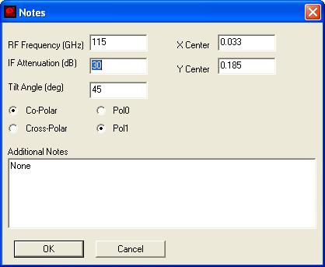
Figure 1- Beam Scan Setup dialog
This dialog window (Figure 1) is presented prior to performing a beam scan. The settings chosen in this dialog window are recorded in a text file which corresponds to the nsi file created during the scan. In this example, the nsi file for the scan is “NRAO FE1 Band3 Jan 2008 Scan 22.nsi”. The notes text file will have the same name as the nsi file, but will have the characters “__NOTES__” appended to the end of the file name. As shown in Figure 2, the notes file contains some of the required data items. The notes file is created in the same directory as the nsi file.

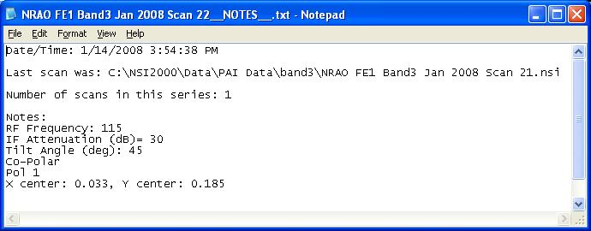
Figure 2- Beam Scan Notes File

Gathering data for all beam scans
The following five items are found in the scan notes file, as described above in section 4.

-Frequency Used For Scan

-Elevation (Tilt) Angle

-Whether the scan is Co-Polar or Cross-Polar

-Whether the scan is for Pol 0 or Pol 1

-IF attenuation (dB) used during scan

Gathering data for Co-Polar beam scans
In addition to the items listed in section 5, the following items are needed for co-polar scans.

Listings and Images (Script-driven Procedure)
The steps in this section are all driven by interaction with dialogs in the NSI2000 script environment. The code for the script file (“Listings and Images.bas”) is attached in Appendix B. If the script file can not be found, then the code may be copied and pasted from this document into the NSI2000 scripting utility in order to run. Alternatively, the individual steps may be performed manually, as described below in section 6.2.

Listings and Images (Script-driven Procedure)

Opening and starting the program
Click on the Script Button, and then browse to the script file using the file browser in the scripting utility. The green Play button starts the script.

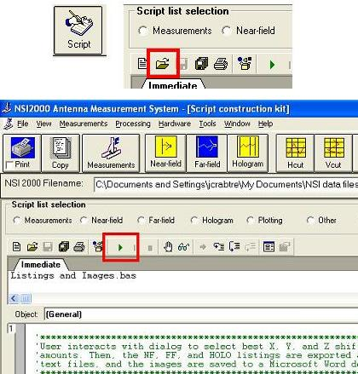
Figure 3- Opening a Script in NSI2000

Select an NSI data file
A file browser window will prompt for the selection of an NSI data file.

Find the optimal XYZ shift amounts
A dialog window will assist the user in finding the best XYZ shift amounts. Be sure to initially select the appropriate Band number, and whether Beam 1, Beam 2, or both beams are to be used.
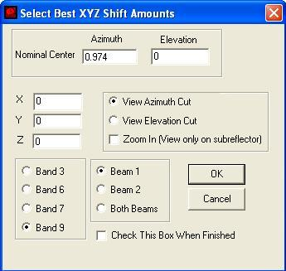
Figure 4- XYZ Shift Amounts Dialog Window

Find the optimal Z shift amount
The goal is to find the X, Y, and Z shift amounts which produce the flattest phase on the subreflector (at the nominal beam center coordinate). The first step is to increase or decrease the Z shift amount until the phase looks flattest at the nominal center coordinates. After the new Z value is entered, hit the OK button in the dialog, and the program will display either an Azimuth or Elevation phase cut, depending on which was selected in the dialog window. The dialog window will return while the phase cut is visible. The user may continue to adjust the Z shift amount and hit the OK button until the best Z shift amount is determined.
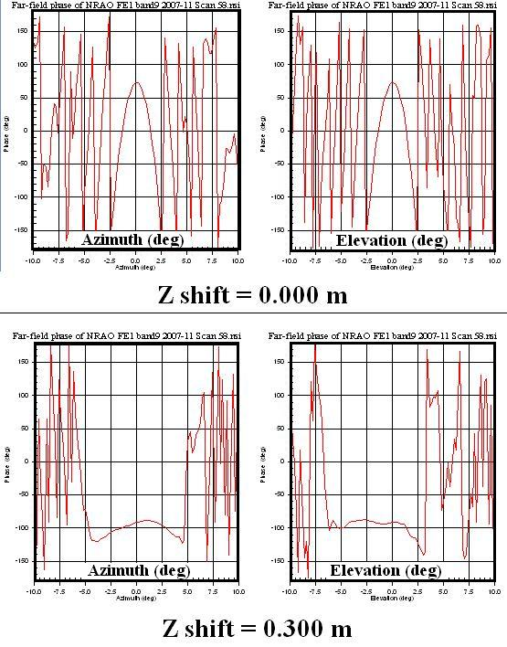
Figure 5- Effect of Z Shift on Phase

Find the optimal X and Y shift amounts
After the best Z shift amount has been determined, it is necessary to find the best X and Y shift amounts. When finding the X value, make sure to select “View Azimuth Cut”. When finding the Y value, select “View Elevation Cut”. Also, be sure to check the “Zoom In” box. This will make it so that only the phase across the subreflector is displayed (See figures below).
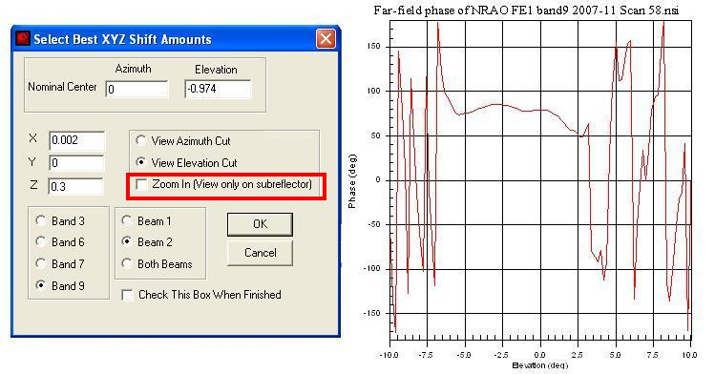
Figure 6- Phase Cut Across Entire Far field

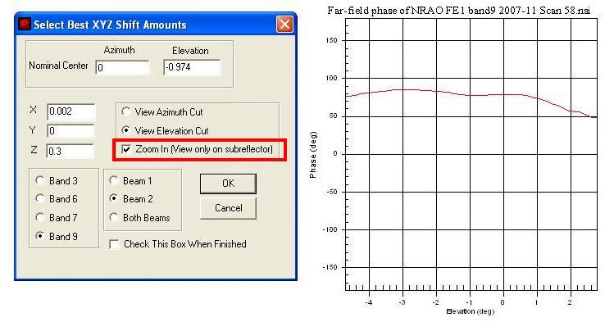
Figure 7- Phase Cut Across Subreflector
The adjustments in the X and Y direction are finer than the Z value shift. Zooming in will make it easier to detect the level of improvement resulting from a new X or Y shift. After the best X and Y values have been determined, it might be useful to tweak the Z shift value a little, and see if the phase improves. After the X, Y and Z shift values have been determined, check the “Check This Box When Finished” box.

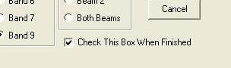
Figure 8- XYZ Shift Dialog finished

Export Listings and Images
After the optimal XYZ shift amounts have been determined, the “Settings for Exported Listings and Images” dialog window will appear. The selected band number, XYZ shift amounts, and beam selection will correspond to the values chosen in the previous dialog, although they may be changed in this dialog if the user wishes to do so. The “Listings” check boxes are used to select which listings will be created. If the “Save Images to Word Doc” box is checked, then a Microsoft Word document will be created containing the following information:
-NSI Scan file name
-X, Y, and Z shift amounts
-Far field listing file header information (Max Global Amplitude, etc.)
-Near field listing file header information (Max Global Amplitude, etc.)
-Far field phase image
-Far field amplitude image
-Hcuts and Vcuts for far field phase on subreflector

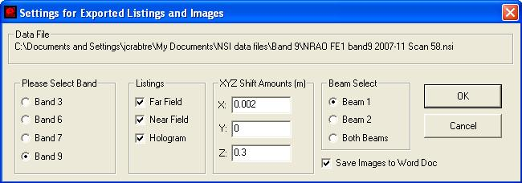
Figure 9- Settings for Exported Listings and Images Dialog
The exported files will each contain the original nsi file name, appended by additional text indicating beam selection, XYZ shift amount, and type of file. The files will all be saved to the same directory as the original nsi scan file. Additionally, the names of the newly created files will be displayed in the NSI2000 debug window.
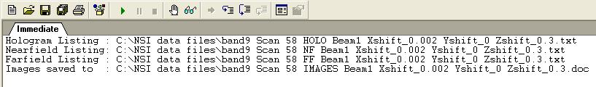
Figure 10- File Names Displayed in NSI2000 Debug Window

Listings and Images (Manual Procedure)
This section is provided in order to instruct the user on how to manually obtain each of the data items obtained in section 6.1. It is highly recommended that the script-driven procedure of 6.1 be used rather than the manual procedure described in this section. However, it is important to know how to get the data manually, for troubleshooting or other purposes.

Maximum global far field amplitude (dB)
This item is found in the far field listing created after a scan, using the “Main Beam Scan Program.bas” script file. The far field listing text file will have the same name as the nsi file, except that it is appended with “FF”, as shown in the title bar of the figure below. The maximum global far field amplitude is outlined in red.
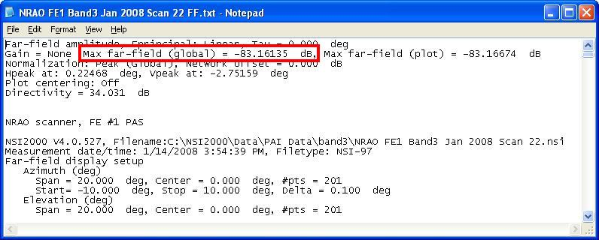
Figure 11- Max Global Amplitude in Far Field text file
If the far field listing can not be found, it can be created with the NSI2000 scripting tool, using the code shown in Figure 4. It is first necessary to open the nsi file created during the scan, and then run the script.
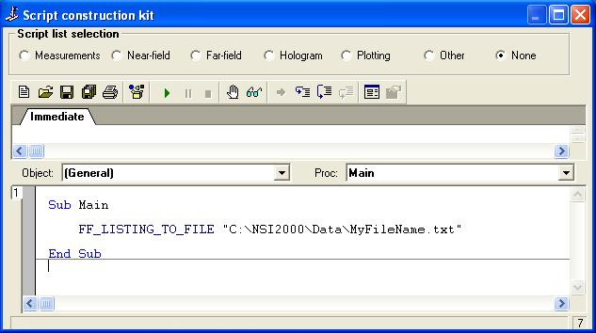
Figure 12- Simple script to create and save Far Field listing

Maximum global near field amplitude (dB)
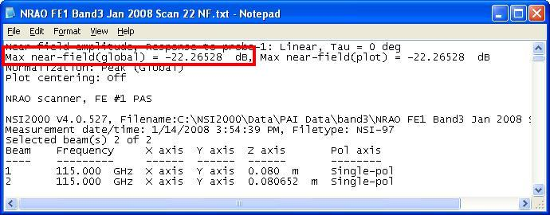
Figure 13- Max Global Amplitude in Near Field text file
The maximum global near field amplitude is found similarly to the procedure described above for the far field. The near field listing text file will have the same name as the nsi file created during the scan, except that it will end with “NF”. If for some reason the near field listing file can not be found, the near field listing may be created using the code shown in figure 4. In this case, the command “FF_LISTING_TO_FILE” would be replaced with “NF_LISTING_TO_FILE”.

Shift amounts (m) applied to the far field transform in the X, Y, and Z directions
It is necessary to determine what amounts by which to shift the far field listing in the X, Y, and Z directions. This is accomplished using the following steps.

- Open the nsi file in NSI2000.
- Double click the Far Field button at the top of the screen. This will open the Far Field setup window.
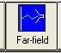
Figure 14- Far Field Button
- Click on each of the three tabs, and make sure the settings are the same as shown in Figures 7, 8, and 9.

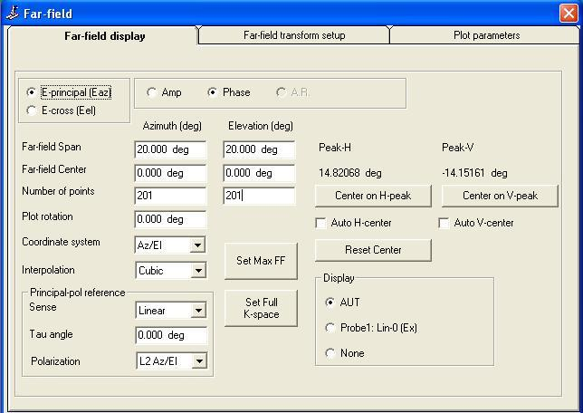
Figure 15- Far field Display Dialog

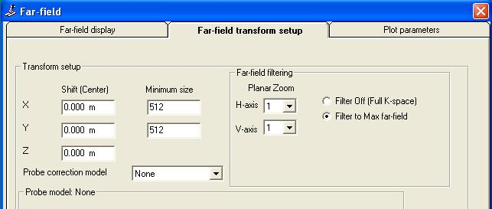
Figure 16- Far Field Transform Setup Dialog

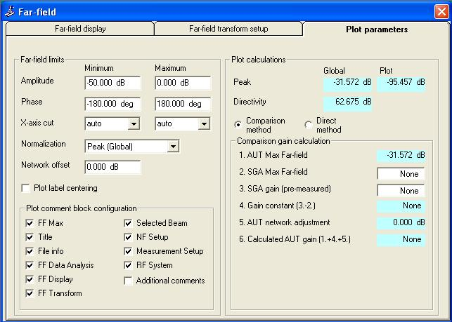
Figure 17- Far field Plot Parameters Dialog

- Click on the “Hcut” and “Vcut” tabs at the top of the screen. This will produce plots of the phase. The Hcut is a plot of the phase at elevation zero degrees, and the Vcut is a plot of the phase at azimuth zero degrees.
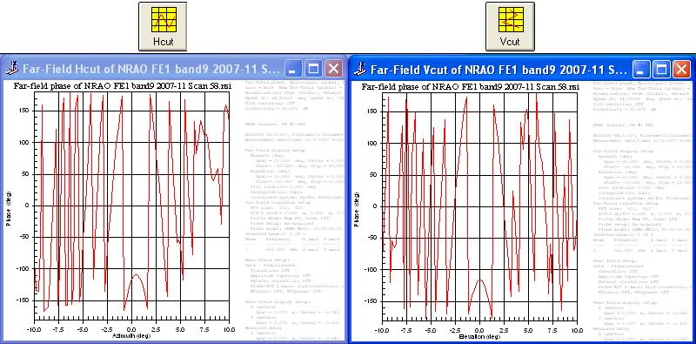
Figure 18- Hcut and Vcut

- The above Hcut and Vcut correspond to X, Y, and Z shift amounts of zero meters (shift amounts shown in Figure 16). Experiment with different Z shift amounts until the phase looks the flattest (around the nominal center points). Once the optimal Z shift amount has been determined, start trying different values for the X shift amount. After the optimal X shift amount has been determined, try using different Y shift amounts. It may not be necessary to apply any shift amount in the X or Y direction. The figure below illustrates an example of this process.

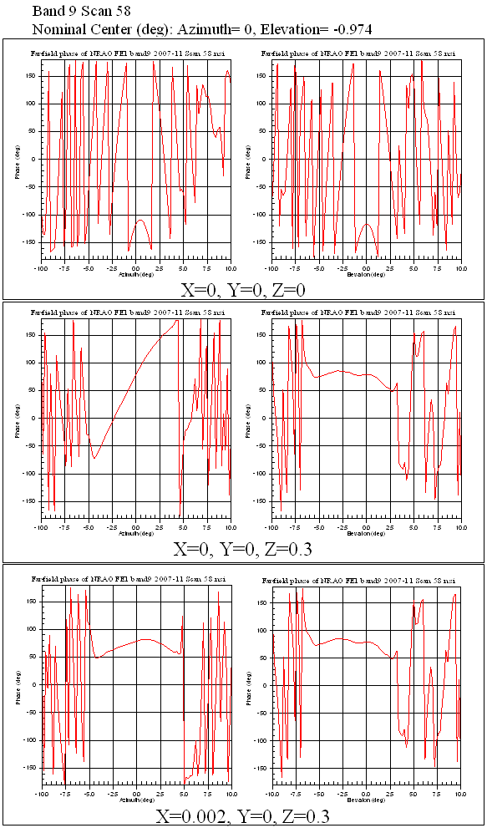
Figure 19- XYZ Shift Example

Hcut (azimuth) and Vcut (elevation) cut images for far field amplitude and phase across subreflector.
- Make sure that plot label centering is turned off.
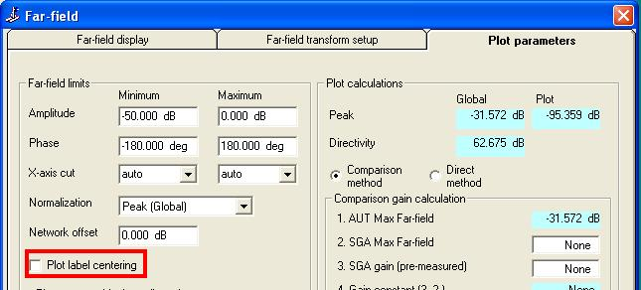
Figure 20- Far Field Plot Label Centering Off
- Apply optimal XYZ shift amounts, as determined using the procedure from section 6.2
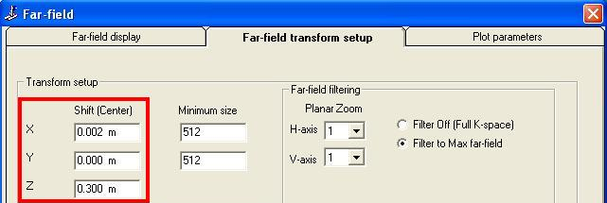
Figure 21- Far Field Transform XYZ Shift Amounts

- Set far field display parameters as shown in the figure below. The Hcut and Vcut images are intended to show the phase across the center of the subreflector. The subreflector has a radius of 3.85 degrees, therefore the span for the images is set to 7.16 degrees (twice the value of the radius). The azimuth and elevation for the center point correspond to the nominal beam center coordinates. In this example for a band 9 scan, the nominal center is 0 (azimuth) and -0.974 (elevation).

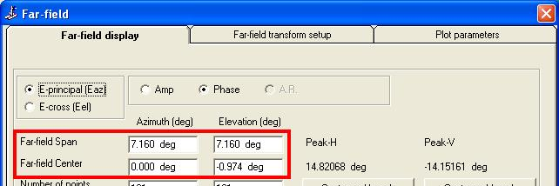
Figure 22- Far Field Span and Center Settings
- Press the Hcut and Vcut buttons to create Hcut and Vcut images.
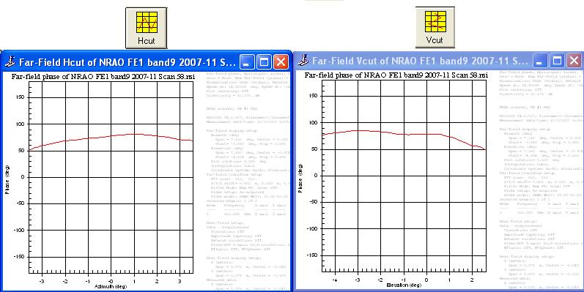
Figure 23- Hcut and Vcut Using XYZ Shift, Centered at Nominal Center Coordinates

Far field amplitude and phase images
Before creating the far field amplitude and phase images, change the display settings as shown below.
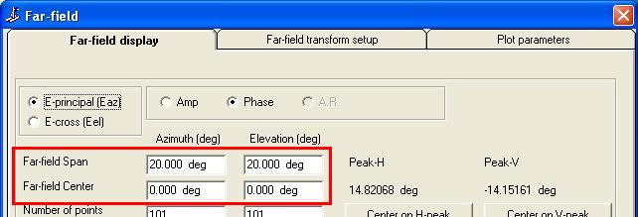
Figure 24- Far Field display settings for Amplitude and Phase Images
- The amplitude image is created by first selecting “Amp” in the far field display dialog, then pressing the “Image” button. Be sure to apply the optimal XYZ shift amounts.
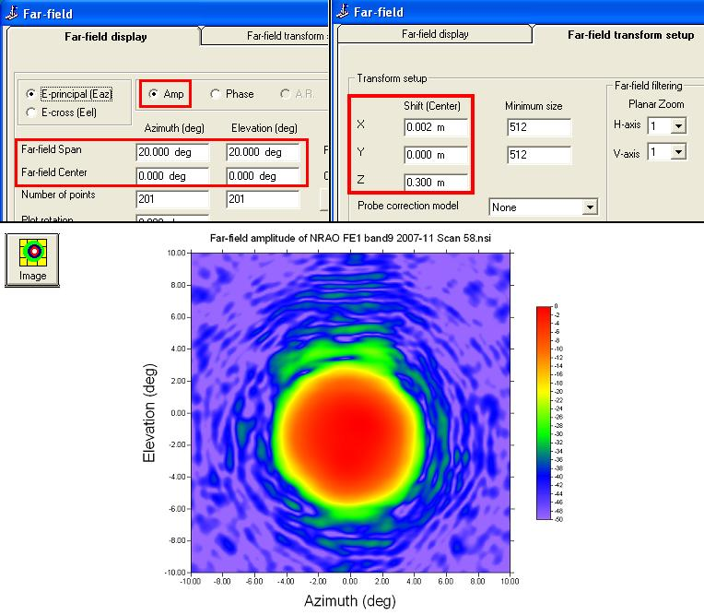
Figure 25- Creating a Far Field Amplitude Image
- The phase image is created similarly, except that “Phase” is selected in the far field display dialog.

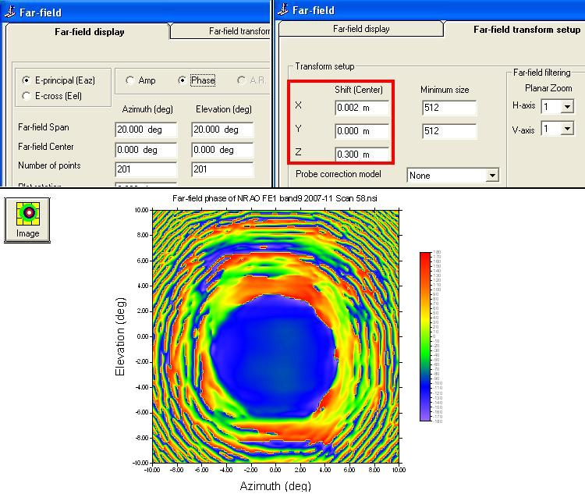
Figure 26- Creating a Far Field Phase Image

Image of phase on subreflector

Calculate beam center coordinates
Open “Beam Efficiency Calculator.xls”, and paste the far field listing into the four columns at the left hand side of the screen.
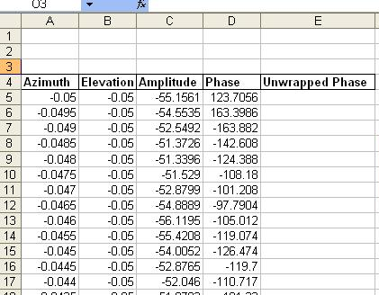
Figure 27- Paste Far Field listing into “Unwrap Phase.xls”
Select the appropriate band number, and then press the “Get Center Values” button.
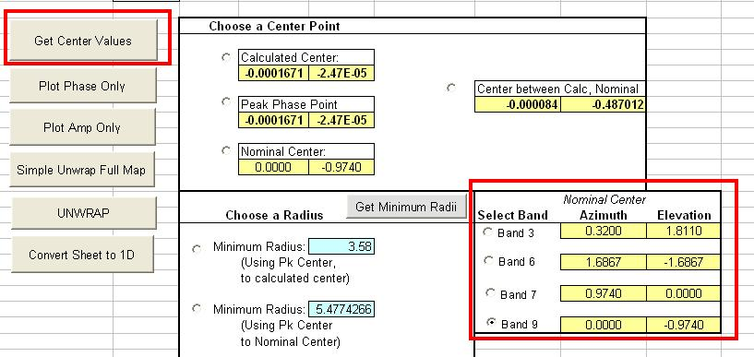
Figure 28- Select Band and Press "Get Center Values" Button
The program will calculate the amplitude center of area for the far field listing. The next step is to plot the phase. The goal is to determine if the phase is unwrapped at two locations:
-Circle with 3.58 degree radius (the radius of the subreflector), centered at the calculate beam center.
-Circle with 3.58 degree radius, centered at the nominal beam center.
After pressing the “Get Center Values” button, the program determines the radius and center coordinates for a circle large enough to encompass the two circles described above.

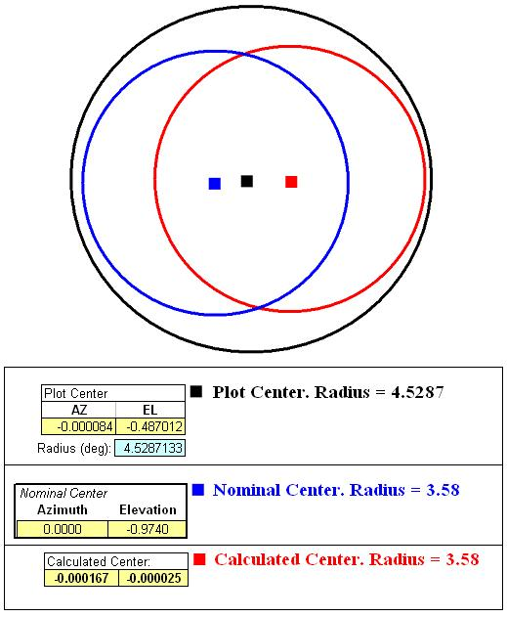
Figure 29- Plot Circle Encompassing Nominal and Calculated Beam Centers

Plot Phase Map
After the center values have been obtained, press the “Plot Phase” button.
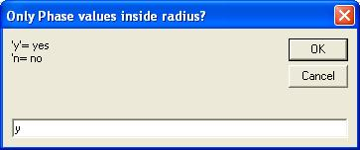
Figure 30- Plot Phase Values Inside Radius Dialog
When the dialog window appears, type “y” so that only the phase map inside the previously calculated circle will be plotted. If the character “n” is entered, the program will plot the entire phase map. The phase map, in either case, is plotted on Sheet 2.

If necessary, unwrap phase
“Wrapping” means that there are 360 degree discontinuities in the phase map. After plotting the phase map in the previous step, it is necessary to inspect the phase map for discontinuities. The figure below shows the difference between a wrapped phase map and an unwrapped phase map.
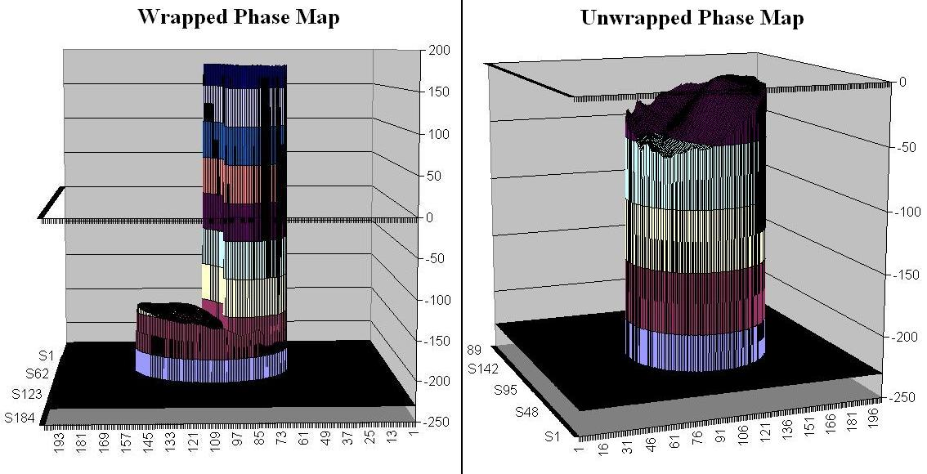
Figure 31- Wrapped Versus Unwrapped Phase Maps
It has been observed that unwrapping will usually be unnecessary if care is taken when determining the best XYZ shift amounts. However, there may be certain beam scans for which unwrapping is unavoidable. The following sections describe the phase unwrapping functions available in the “Beam Efficiency Calculator.xls” application.

Simple Unwrap Full Map
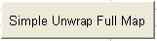
Figure 32- Simple Unwrap Full Map Button
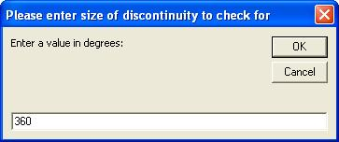
Figure 33- Discontinuity Value Request Dialog
The “Simple Unwrap Full Map” button causes a simple unwrapping algorithm to be executed across the full phase map. After pressing this button, a dialog will prompt for the size of discontinuity for which to check. The default value is 360, and that will almost always be the only value necessary. There may be occasions when 180 degree discontinuities are present in the phase map after an unwrapping attempt, in which case a value of 180 would be entered. The resulting phase map is plotted on Sheet 4, and the resulting phase listing is copied to the “Phase” column in Sheet 1. This approach will most likely not unwrap the entire phase map completely, but it may have the effect of unwrapping within the circle of interest (Figure 30). In order to verify this, press the “Plot Phase” button to plot the new phase map onto Sheet 2.)
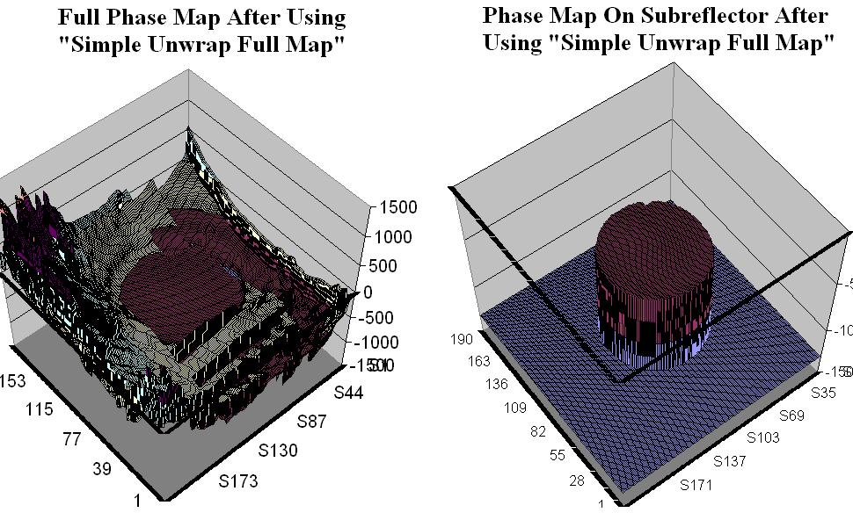
Figure 34- Phase Maps After Using "Simple Unwrap Full Map"

Unwrap

Selecting a center point
The first step when selecting a center point is to choose the appropriate band.
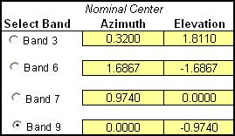
Figure 35- Selecting the Appropriate Band
After selecting a band, the nominal center values for that band are copied to the “Nominal Center” field in the “Choose a Center Point” section. The “Calculated Center” field contains the center values obtained after pressing the “Get Center Values” button. The “Peak Phase Point” is initially the same as the calculated center. However, a user may enter different values in this field, which will affect the minimum radii values available (discussed below).
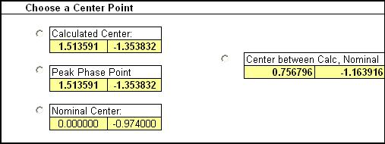
Figure 36- Selecting a Center Point

Selecting a radius
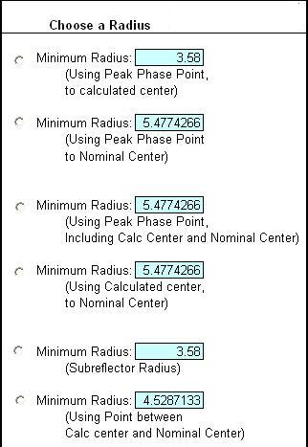
Figure 37- Selecting a Radius

First Radius Option
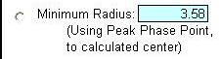
Figure 38- First Radius Option
This option pertains to a circle centered at the Peak Phase Point. The radius is large enough to include a circle (with a radius of 3.58 degrees) centered at the Calculated Center. This option will only be used if the user has entered in a Peak Phase Point that is different from the Calculated Center.

Second Radius Option
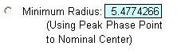
Figure 39- Second Radius Option
This option pertains to a circle centered at the Peak Phase Point. The radius is large enough to include a circle (with a radius of 3.58 degrees) centered at the Nominal Center. This option will only be used if the user has entered in a Peak Phase Point that is different from the Calculated Center.

Third Radius Option
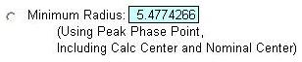
Figure 40- third Radius Option
This option pertains to a circle centered at the Peak Phase Point. The radius is large enough to include two other circles. The first other circle (with a radius of 3.58 degrees) is centered at the Nominal Center, and the second (also with a radius of 3.58 degrees) is centered at the Calculated Center. This option will only be used if the user has entered in a Peak Phase Point that is different from the Calculated Center.

Fourth Radius Option
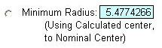
Figure 41- Fourth Radius Option
This option pertains to a circle centered at the Calculated Center Point. The radius is large enough to include a circle (with a radius of 3.58 degrees) centered at the Nominal Center.

Fifth Radius Option
This option pertains to a circle centered at any of the user-selected center points. The radius is 3.58 degrees, which is the radius of the subreflector.
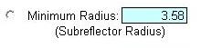
Figure 42- Fifth Radius Option

Sixth Radius Option

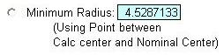
Figure 43- Sixth Radius Option
This option pertains to a circle centered at the midway point between the Calculated Center and the nominal Center. The radius is large enough to include two other circles. The first other circle (with a radius of 3.58 degrees) is centered at the Nominal Center, and the second (also with a radius of 3.58 degrees) is centered at the Calculated Center.

Number of Iterations
The last step before pressing the “Unwrap” button is to enter the number of times the algorithm will iterate. This number will almost always be 1, but the user may set it higher if deemed necessary.
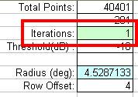
Figure 44- Enter the Number of Iterations

Unwrap Button
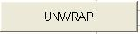
Figure 45- Unwrap Button
The “Unwrap” button causes an unwrapping algorithm to be executed only within the user defined circle in the phase map. The user is first asked for the value of discontinuity for which to check, as previously described, after which the unwrapping algorithm is performed. The resulting phase map is plotted on Sheet 4, and the resulting phase listing is copied to the “Phase” column in Sheet 1.

Specific Approaches to Phase Unwrapping
The process of unwrapping phase can be lengthy and may cause frustration. It is highly recommended that the user spend additional time adjusting the XYZ shift amounts in order to decrease the likelihood that unwrapping will be necessary. However, if unwrapping can not be avoided, the specific approaches may prove helpful. Sometimes a combination of these approaches is necessary.

Approach 1- Simple Unwrap, then Unwrap
Using this approach, perform the “Simple Unwrap Full Map” step as described above. Afterward, copy the “Unwrapped Phase” column into the “Phase” column. Then press the “Unwrap” button. This approach is useful if the original phase map was wrapped in numerous places within the circle of interest, and the “Simple Unwrap” was able to reduce the amount of wrapping.

Approach 2- Use 360 deg, then 180 deg discontinuity value
This approach may be useful if an initial unwrapping attempt appeared to be almost successful, but has caused 180 degree discontinuities to remain in the map.

Approach 3- Try different center points and/or radii

Approach 4- Find a “Peak Phase Point” through visual inspection
Sometimes a phase map will contain wrapping in the form of sharply defined concentric rings. In this approach, the center point of the concentric rings is determined, and used as the center for unwrapping.

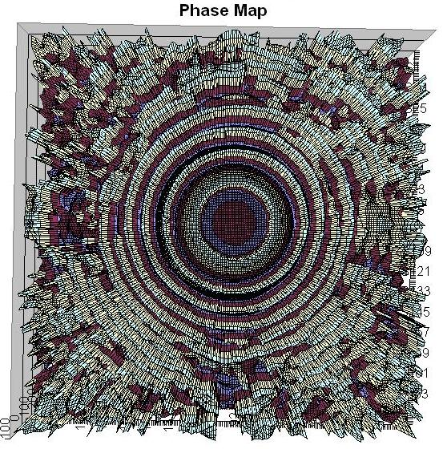
Figure 46- Wrapped Phase Map with Sharply Defined Concentric Rings
- The first step in this approach is to set the Plot Center to (5, 5), and set the radius to 5 degrees. Then hit the “Plot Phase” button, and type “y” at the prompt asking if only the phase inside the radius should be plotted.

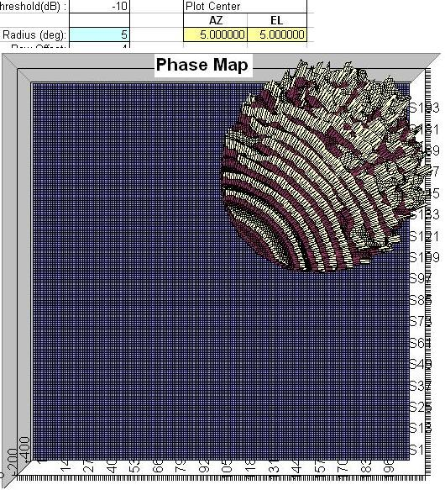
Figure 47- Wrapped Phase. Radius=5, Center= (5,5).
The result is plotted on Sheet 2. Orient the plot so that the phase circle is located at the upper right hand corner.
- The next step is to select a Plot Center location of (0, 0), and then plot the phase again.
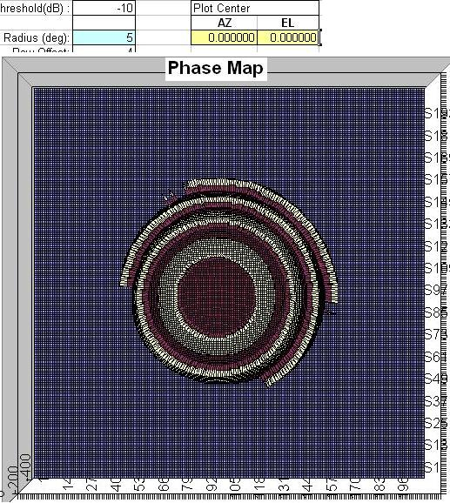
Figure 48- Wrapped Phase. Radius=5, Center= (0,0).
- At this point start adjusting the center coordinates until the phase map appears to be centered at the center of the concentric rings. In this example, the center was determined to be located at (-0.5, -0.5).
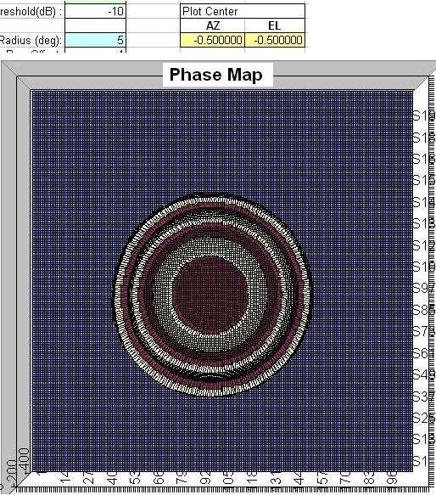
Figure 49- Wrapped Phase. Radius=5, Center= (-0.5, -0.5).
- After the peak phase point has been determined, enter this value into the “Plot Center” section as well as the “Peak Phase Point” section.
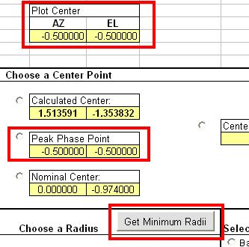
Figure 50- Enter Peak Phase Point values and Press "Get Minimum Radii" button.
- The next step is to select the desired radius, and proceed with unwrapping according to any of the procedures previously described.

Approach 5- Manually adjust points in a 2-d phase map
This approach should generally be avoided. However, if unwrapping attempts continually result in a phase map that is completely unwrapped except for a very small number of data points, this approach may be the only viable option. In this example, a phase map has a small set of data points which protrude above the surrounding data.
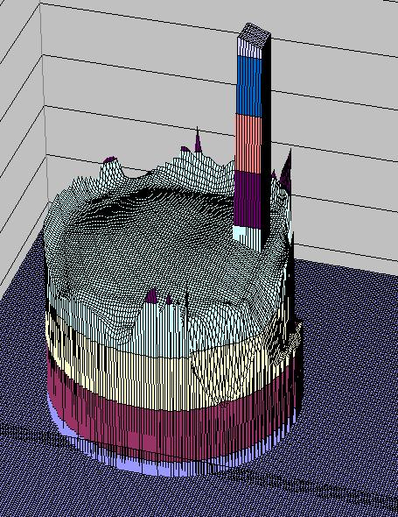
Figure 51- Phase Map with Small Patch of Wrapped Data Points
Close inspection of the data reveals that the values appear to be 360 degrees higher than the immediately surrounding points.
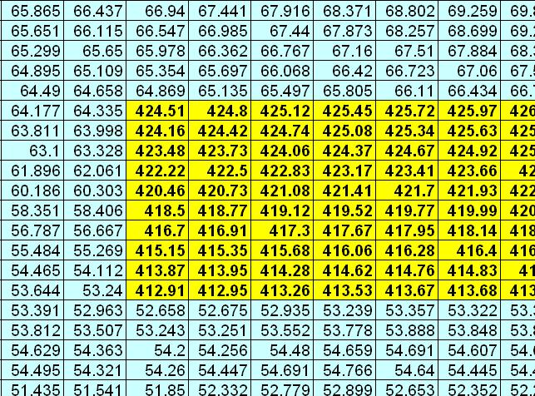
Figure 52- Data Points Where Wrapping Has Occurred
The solution is to simply subtract 360 from each of the data points in the wrapped region (shaded in yellow in Figure 51). It should be noted that the discontinuity may be larger or smaller than 360, depending on how many attempts at unwrapping have been performed. It is best to first determine the size of the discontinuity at one of the points. After subtracting (or adding, if required) the value of discontinuity at each point, it is necessary to inspect the plot image again to verify that the unwrapping has been successful.
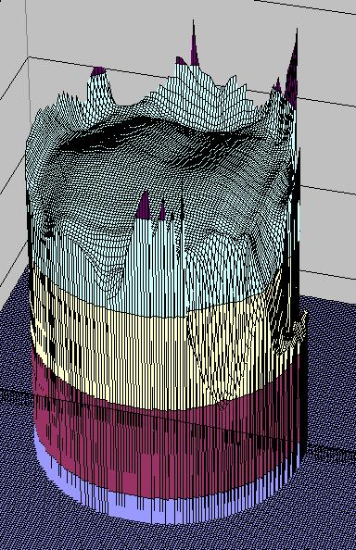
Figure 53- Phase Map After Manually Unwrapping A Small Section
If the result looks satisfactory, it is then necessary to copy the contents of the current sheet into the “Phase” column on Sheet 1. This is achieved by first pressing the “Convert Sheet to 1D” button, and then specifying which sheet is to be copied.
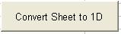
Figure 54- Convert Sheet to 1D button
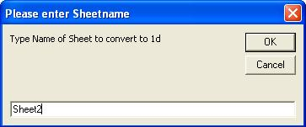
Figure 55- Specify Which Sheet Is To Be Copied

Notes about phase unwrapping
      - If an attempt at phase unwrapping is successful, it is recommended that the file be saved using a name something like “Phase Unwrap Band 9 Scan 58.xls”.

Get Image of Phase Map
The image of the phase will be displayed on either Sheet 2 or Sheet 4, depending on which steps were used for plotting and/or unwrapping.

Beam Efficiency Data

Open “Beam Efficiency Calculator.xls”
This file should already be open after the previous step. The four columns at the left hand side (Azimuth, Elevation, Amplitude, Phase) should contain the far field listing after the previous step.

Select Band Number
Figure 56- Select Band Number

Press “Get Center Values” button
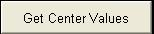
Figure 57- “Get Center Values” Button

Press “Get Beam Efficiencies” button
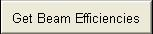
Figure 58- "Get Beam Efficiencies" button
This cause the program to calculate beam efficiency values. The resulting data will be displayed on the “Efficiencies” sheet.
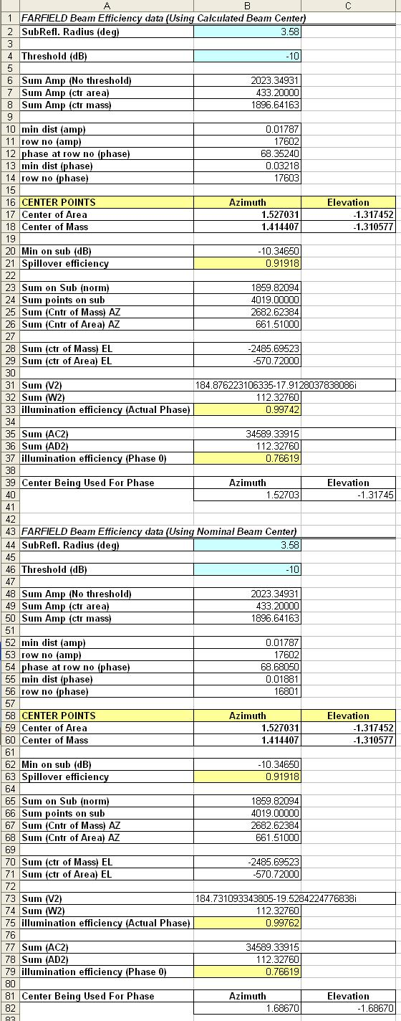
Figure 59- "Efficiencies" Sheet

Beam center coordinates for near field and hologram
In order to get the beam center coordinates for the near field, paste the Nearfield listing into the “Beam Efficiency Calculator.xls” sheet. Then press the “Get Center Values” button. The calculated center will be displayed in three locations- the “Calculated Center” fields, the “Plot Center” fields, and the “Peak Phase Point” fields. Repeat this process with the hologram listing to get the beam center for the hologram.

Plot picture of far field beam center points
After the efficiency data has been calculated for all of the co-polar beam scans, it is necessary to plot the locations of the calculated far field beam centers with respect to the nominal beam center. The center values may either be obtained from the “Phase Unwrap.xls” sheet, or the beam efficiency data described in section 6.4.

Open “Draw Circles and Points.vi” in LabView.
There will be a point plotted for each co-polar beam scan.

Determine number of points being plotted
There will be a point plotted for each co-polar beam scan.

Modify block diagram to accommodate the appropriate number of points
Go to the block diagram. For each point being plotted, there will be this diagram:
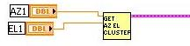
Figure 60- LabView Diagram Components for a Single Point
So, for example, if four points are to be plotted, the diagram will look like this:
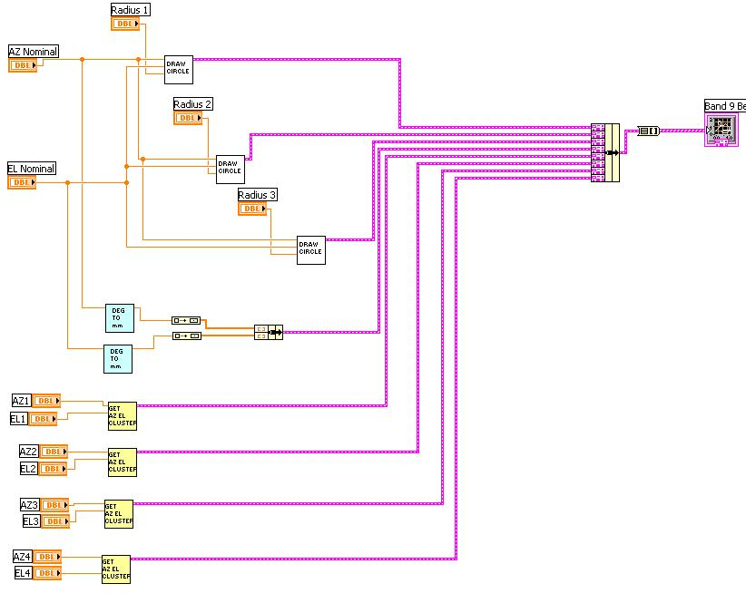
Figure 61- Block Diagram for Plotting Four Points
If only two points are to be plotted, the block diagram will look like this:
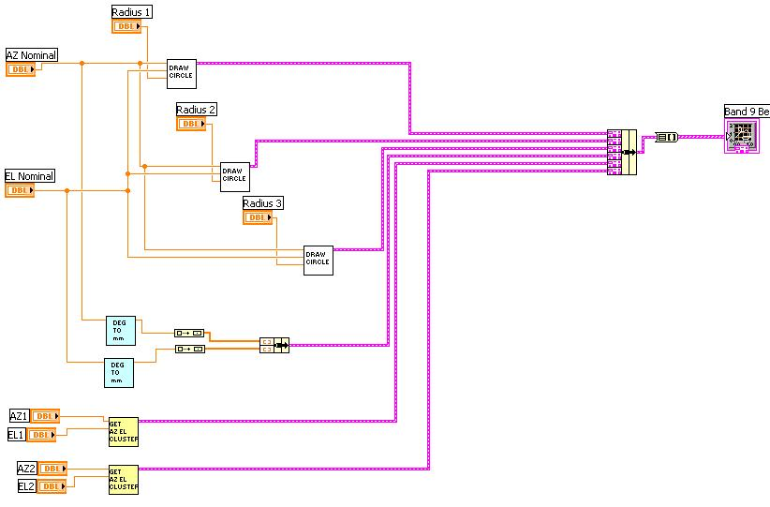
Figure 62- Block Diagram for Plotting Four Points

Enter beam center coordinates at front panel
The front panel has a section for beam center coordinates. The two controls at the top, “AZ Nominal” and “EL Nominal”, will have azimuth and elevation values for the nominal center. The rest of these controls will contain the azimuth and elevation values for each of the calculated beam centers.
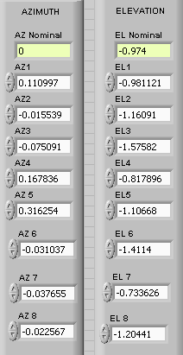
Figure 63- Front Panel Beam Coordinate Controls

Plot the values
Hit the start button in LabView, and the points will be plotted in the graph.
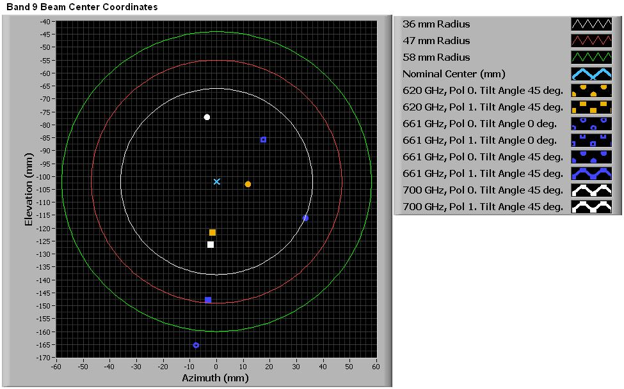
Figure 64- Plotted Beam Center Points

Put the appropriate names in the plot legend
Figure 65- Plot Name
The name should refer to the frequency, pol number, and tilt angle used in the scan.

Use the same color for all scans at the same frequency
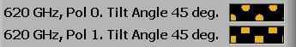
Figure 66- Plot Legend Same Color for Same Frequency

Use circle point style for Pol 0, and square point style for Pol 1
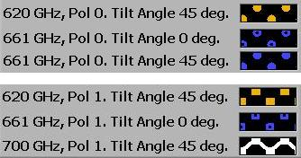
Figure 67- Pol 0 with Circles, Pol 1 with Squares

Use hollow point style for Tilt Angle of 0, solid point style for tilt angle of 45.
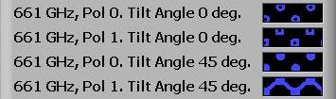
Figure 68- Solid points for 45 degree tilt, Hollow points for 0 degree tilt
There may be more than two tilt angles among the scans being used. If that is the case, there are other ways to differentiate the appearance of the points.

Gathering Data for cross-polar beam scans
In addition to the items listed in section 5, the following item is needed for cross-polar scans.

Far field amplitude image
This image is obtained using the procedure described above in section 6.5.

Putting the data together
After the data has all been collected, it is time to put it all together.

Open the “Collected Data.xls” spreadsheet

Create a sheet for each beam scan
The name of the sheet should contain frequency, Pol number, Co-Pol or X-Pol, and Elevation angle.
Figure 69- Sheet Names
The sheets should be arranged by frequency, sub arranged by tilt angle, further sub arranged by Pol number, and Co-Pol/Cross. For example, if 12 scans were performed, where the first 8 were at 200 GHz, and the last four were at 500 GHz, the sheet order would look something like this:
- 200 GHz, Pol 0, Co-Pol, Elevation 0
- 200 GHz, Pol 0, Cross-Pol, Elevation 0
- 200 GHz, Pol 1, Co-Pol, Elevation 0
- 200 GHz, Pol 1, Cross-Pol, Elevation 0
- 200 GHz, Pol 0, Co-Pol, Elevation 45
- 200 GHz, Pol 0, Cross-Pol, Elevation 45
- 200 GHz, Pol 1, Co-Pol, Elevation 45
- 200 GHz, Pol 1, Cross-Pol, Elevation 45
- 500 GHz, Pol 0, Co-Pol, Elevation 0
- 500 GHz, Pol 0, Cross-Pol, Elevation 0
- 500 GHz, Pol 1, Co-Pol, Elevation 0
- 500 GHz, Pol 1, Cross-Pol, Elevation 0
The above order is recommended, but it is not necessary if there aren’t a complete set of scans for a certain frequency. There also may be more than one scan at exactly the same settings. In this case it is good to put the extra scans at the end of the set with the same frequency. For example, if there were a complete set of four scans done at a tilt angle of 45 degrees, and then two more scans were done at the same setting as one the first scan, the order would look something like this:
- 200 GHz, Pol 0, Co-Pol, Elevation 0
- 200 GHz, Pol 0, Cross-Pol, Elevation 0
- 200 GHz, Pol 1, Co-Pol, Elevation 0
- 200 GHz, Pol 1, Cross-Pol, Elevation 0
- 200 GHz, Pol 0, Co-Pol, Elevation 0 (second scan at this setting)
- 200 GHz, Pol 0, Co-Pol, Elevation 0 (third scan at this setting)

Enter the settings for each beam scan on each sheet
The settings for each beam scan will be at the top left corner of each sheet. Fill in the fields with the appropriate information for the scan. The information for this section was obtained as described in Section 4 (see also Figure 2).
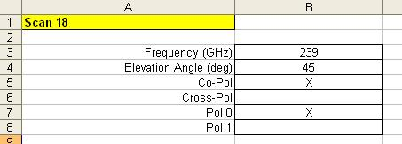
Figure 70- Settings for Beam Scan

If Co-Polar, Copy and paste the beam efficiency data into the sheet
This data was obtained as described in Section 6.4 (see also Figure 61).
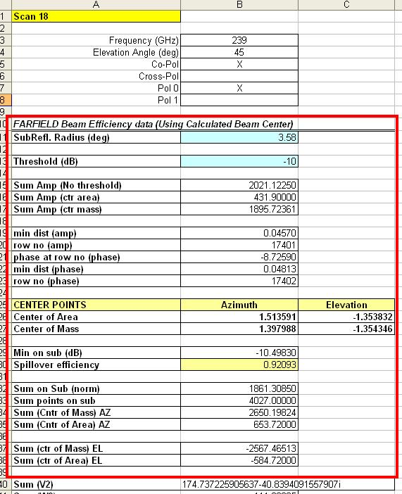
Figure 71- Paste Efficiency Data Into Spreadsheet

If Co-Polar, Enter the Maximum Global Amplitude and IF Attenuation values for the Far field and near field listings
The IF attenuation value was obtained as described in Section 5 (see also Figure 2). The Max Global map values are found in the Microsoft Word document created using the script-driven procedure, as described in Section 6.1.4. If the script-driven procedure was not used, then the Max Global Amp values were obtained as described in Sections 6.2.1 and 6.2.2 (see also Figures 11 and 13).
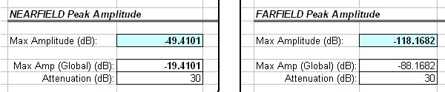

If Cross-Polar, Enter the Maximum Global Amplitude and IF Attenuation values for the Far field listing
This is the same as was done for the co-polar scan, but the near field data is not required.

If Co-Polar, enter the center values for the near field and hologram listings
This data was obtained as described in Section 6.5.
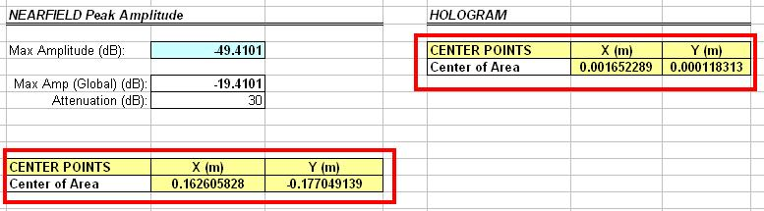
Figure 72- Center Points for Near Field and Hologram Listings

If Co-Polar, enter the XYZ shift amounts
These values were obtained as described in Section 6.1.3 (script-driven procedure) and Section 6.2.3 (manual procedure).
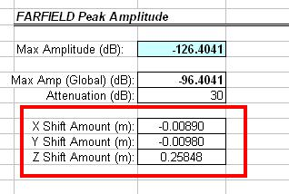
Figure 73- XYZ Shift Amounts

If Co-Polar, copy and paste the following images into the sheet:
- Far field amplitude
- Far field phase
- Far field Hcuts (amplitude and phase)
- Far field Vcuts (amplitude and phase)
- Far Field Phase on subreflector
This information was obtained according to the procedures described in Sections 6.1.4, 6.2.4, 6.2.5 and 6.3.
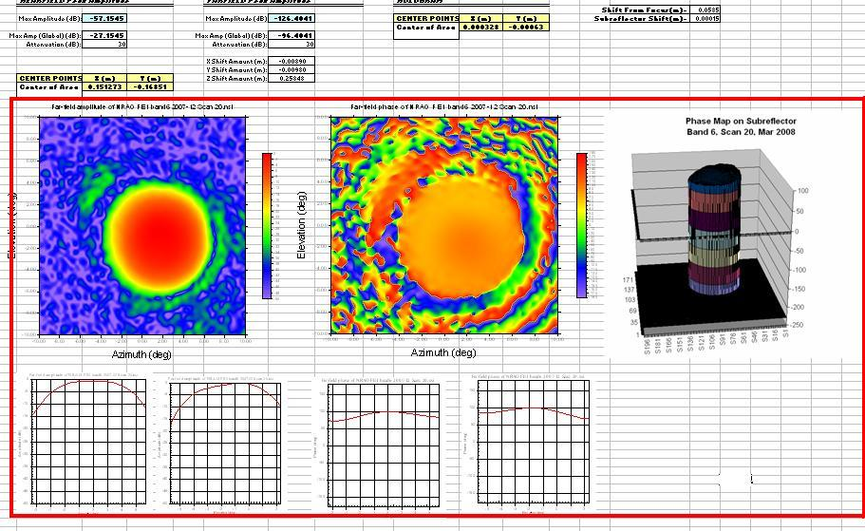
Figure 74- Images Pasted into Sheet

Enter the appropriate azimuth and elevation values for the nominal beam center at the top of the main page
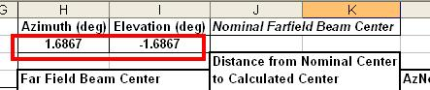

Press the “Populate Cells” button on the main page
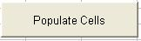
Figure 75- Populate Cells Button
Once all the sheets have been filled in and the nominal beam center values have been entered, press the “Populate Cells” button on the main page. This will collect and calculate all of the data needed for the main page.
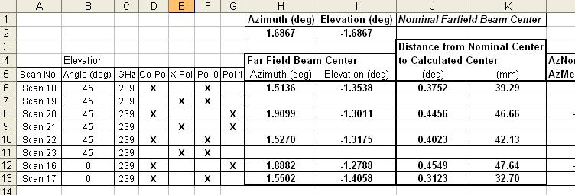
Figure 76- Snippet of Main Page Data

Copy and past the picture of the Beam Center plot on the main page
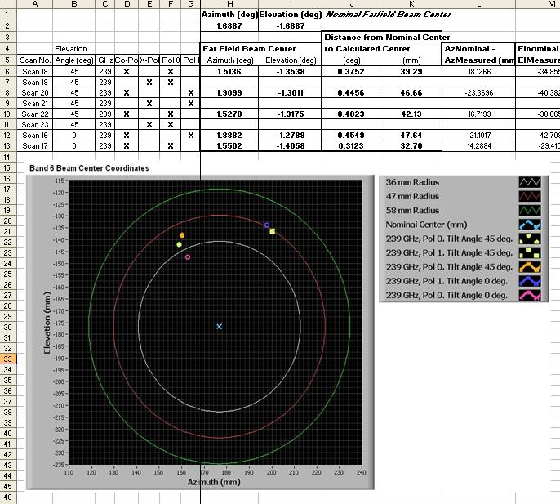
Figure 77- Main Page with Beam Center Plot

Important notes regarding the Collected Data sheet
Make sure to paste everything into the correct cells in the template sheets. The “Collected Data.xls” spreadsheet has blank template sheets for co-polar and cross-polar scans. It is important to follow these templates. The “Populate Cells” button triggers a macro which reads data from specific cells in each sheet. If any of the data is in the wrong cell, then it won’t be read.
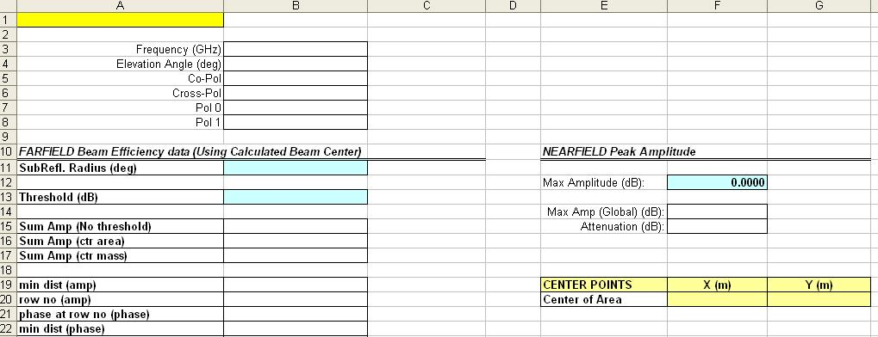
Figure 78- Blank Sheet for Co-Polar Beam Scan

Appendix A- “Main Beam Scan Program.bas”
The following code is used to perform beam scans and create far field, near field, and hologram listings after each scan. If the script file can not be found, this code may be copied and pasted into the NSI2000 scripting utility and run.

'********************
'* Main Scan Program
'********************

Sub Main
On Error Goto labelEnd
Debug.Clear
Dim Zposition As String
Dim BeginningScanNumber As Integer
Dim NumberOfScans As Integer
Dim filenumber As String
Dim filename1 As String
Dim filename2 As String
Dim count As Integer
Dim Zpos As Double
Dim AxisName As String
Dim lZ As Long
Dim k As Integer
Dim FileNamePrefix As String
Dim PrefixAndNumber As Variant
Dim tmpName As String
Dim NoteFileName As String

'********************************************************
' Get information to make file names.
'********************************************************
tmpName = DATA_FILENAME
PrefixAndNumber = GetPrefixAndNumber(tmpName)
FileNamePrefix = PrefixAndNumber(0)
BeginningScanNumber = CInt(PrefixAndNumber(1))

'********************************************************
' Get current value for Z distance for Beam 1.
' Move Z axis to that position.
'********************************************************

'find beam table column index for Z-Axis
For k = 1 To BeamTable.AxesCount
If BeamTable.AxisName(CLng(k)) = "Z axis" Then
lZ = k
End If
Next k

'get Z-Axis position for first beam
Zposition = CStr(BeamTable.Item(1).PositionArray(lZ))
Debug.Print "Z position " & Zposition
MOVE_TO_SCAN_CENTER
CONTROLLER_AUX_AXIS_SET("Z axis")
CONTROLLER_AUX_AXIS_MOVE Zposition

BeginningScanNumber = CInt(PrefixAndNumber(1))
'Debug.Print "Beginning Scan number = " & BeginningScanNumber

'********************
' Perform Scans
'********************
NumberOfScans = InputBox("", "Enter the number of Scans")
If (CStr(NumberOfScans) = "" Or NumberOfScans = 0) Then
GoTo labelEnd
End If

NoteFileName = CreateTextFile(NumberOfScans, FileNamePrefix, BeginningScanNumber)

Debug.Print "Performing " & NumberOfScans & " scans"
BeginningScanNumber = BeginningScanNumber - 1

'Debug.Print "Beginning Scan number = " & BeginningScanNumber
count = 0
For I = (BeginningScanNumber+1) To (BeginningScanNumber + NumberOfScans)
filename1 = FileNamePrefix + CStr(I) + ".nsi"

CONTROLLER_AUX_AXIS_SET("Z axis")
CONTROLLER_AUX_AXIS_MOVE Zposition
MOVE_TO_SCAN_CENTER
CONTROLLER_AUX_AXIS_SET("Z axis")
CONTROLLER_AUX_AXIS_MOVE Zposition

'Important: Leave these two lines exactly as they are
MEAS_CREATE_NEW_SCAN
MEAS_ACQUIRE filename1, True
CONTROLLER_AUX_AXIS_SET "Z axis"
CONTROLLER_AUX_AXIS_MOVE Zposition
Debug.Print filename1
count = count + 1
Next I

Debug.Print "Scans completed."
Debug.Print vbCrLf

'*******************************
' Create Far-Field Listings
'*******************************
For J = (BeginningScanNumber+1) To (BeginningScanNumber + NumberOfScans)
filename1 = FileNamePrefix + CStr(J) + ".nsi"
filename2 = FileNamePrefix + CStr(J) + " FF.txt"
DATA_FILENAME = filename1

If FF_PLOTCENTERING = 1 Then
FF_PLOTCENTERING_OFF
End If

SELECT_BEAM 1
SELECT_BEAM 2, 1
FF_LISTING_TO_FILE filename2
Debug.Print filename2
Next J
Debug.Print "FF listings completed"

'*******************************
' Create Near-Field Listings
'*******************************
For J = (BeginningScanNumber+1) To (BeginningScanNumber + NumberOfScans)
filename1 = FileNamePrefix + CStr(J) + ".nsi"
filename2 = FileNamePrefix + CStr(J) + " NF.txt"
DATA_FILENAME = filename1

If NF_PLOTCENTERING = 1 Then
NF_PLOTCENTERING_OFF
End If

SELECT_BEAM 1
SELECT_BEAM 2, 1
NF_LISTING_TO_FILE filename2
Debug.Print filename2
Next J
Debug.Print "NF listings completed"

'*******************************
' Create Hologram Listings
'*******************************
For J = (BeginningScanNumber+1) To (BeginningScanNumber + NumberOfScans)
filename1 = FileNamePrefix + CStr(J) + ".nsi"
filename2 = FileNamePrefix + CStr(J) + " HOLO.txt"
DATA_FILENAME = filename1

If HOLO_PLOTCENTERING = 1 Then
HOLO_PLOTCENTERING_OFF
End If

SELECT_BEAM 1
SELECT_BEAM 2, 1
HOLO_LISTING_TO_FILE filename2
Debug.Print filename2
Next J
Debug.Print "HOLOGRAM listings completed"
Debug.Print "Notes saved to file: " & NoteFileName

'Open the last nsi file created
DATA_FILENAME = filename1

labelEnd:
End Sub

Function GetPrefixAndNumber(tmp As String) As Variant
Dim lengthSuffix As Long
Dim tmpchar As String
Dim count As Integer
Dim done As Boolean
Dim AscVal As Integer
Dim ResultArray(2) As String
Dim prefix As String
Dim ScanNumber As String

count = 0
done = False
lengthSuffix = 4

Do While done = False
tmpchar = Mid(tmp, Len(tmp) - 4 - count, 1)
AscVal = Asc(tmpchar)
lengthSuffix = lengthSuffix + 1

If (AscVal <48) Or (AscVal > 57) Then
done = True
lengthSuffix = lengthSuffix - 1
End If
count = count + 1
Loop

prefix = Left(tmp, Len(tmp)-lengthSuffix)
ScanNumber = Left(Right(tmp, lengthSuffix), lengthSuffix - 4)
ResultArray(0) = prefix
ResultArray(1) = ScanNumber

GetPrefixAndNumber = ResultArray

End Function

Function CreateTextFile(NumberOfScans As Integer, FileNamePrefix As String, FirstScanNumber As Integer) As String

Dim notes As String
Dim filename As String
Dim tmpstr As String
Dim tmpchar As String
Dim done As Boolean
Dim filenum As Integer
Dim count As Long
Dim lengthEND As Long
Dim CoCross As String
Dim PolNum As String
Dim FirstScanNum As Integer

FirstScanNumber = FirstScanNumber + 1

Begin Dialog UserDialog 550,287,"Notes" ' %GRID:10,7,1,1
TextBox 150,42,100,21,.AttenValue
TextBox 150,70,100,21,.TiltAngleValue
OptionGroup .Group1
OptionButton 10,98,20,14,"CoPolButton",.OptionButton1
OptionButton 10,119,20,14,"CrossPolButton",.CrossPolButton
Text 40,98,80,14,"Co-Polar",.Text1
Text 40,119,100,14,"Cross-Polar",.Text2
TextBox 150,14,100,21,.FrequencyValue
Text 10,21,130,21,"RF Frequency (GHz)",.Text3
Text 10,42,130,21,"IF Attenuation (dB)",.Text4
Text 10,70,130,21,"Tilt Angle (deg)",.Text5
TextBox 370,14,100,21,.XcenterValue
Text 300,21,70,14,"X Center",.Text6
TextBox 370,42,100,21,.YcenterValue
Text 300,49,60,14,"Y Center",.Text7
OptionGroup .Group2
OptionButton 160,98,20,14,"OptionButton2",.Pol0Button
OptionButton 160,119,20,14,"Pol1Button",.OptionButton3
Text 190,98,60,14,"Pol0",.Text8
Text 190,119,50,14,"Pol1",.Text9
TextBox 10,161,530,84,.AdditionalNotesValue
Text 10,147,240,14,"Additional Notes",.Text10
OKButton 20,259,120,21
CancelButton 160,259,120,21
End Dialog
Dim dlg As UserDialog

dlg.XcenterValue = CStr(Round(MEAS_HCENTER, 5))
dlg.YcenterValue = CStr(Round(MEAS_VCENTER, 5))
dlg.FrequencyValue = MEAS_FREQUENCY
dlg.AttenValue = "0"
dlg.TiltAngleValue = "0"
dlg.AdditionalNotesValue = "None"

Dialog dlg

If dlg.group1 = 0 Then
CoCross = "Co-Polar"
End If
If dlg.group1 = 1 Then
CoCross = "Cross-Polar"
End If
If dlg.group2 = 0 Then
PolNum = "Pol 0"
End If
If dlg.group2 = 1 Then
PolNum = "Pol 1"
End If

SELECT_BEAM 1
notes = "RF Frequency: " & dlg.FrequencyValue & vbCrLf
notes = notes & "IF Attenuation (dB)= " & dlg.AttenValue & vbCrLf
notes = notes & "Tilt Angle (deg): " & dlg.TiltAngleValue & vbCrLf
notes = notes & CoCross & vbCrLf
notes = notes & PolNum & vbCrLf
notes = notes & "X center: " & dlg.XcenterValue & ", Y center: " & dlg.YcenterValue
notes = notes & vbCrLf & vbCrLf & dlg.AdditionalNotesValue

'MsgBox (notes, vbOkOnly, "Notes")

tmpstr = DATA_FILENAME
done = False
count = 1

Do While done = False
tmpchar = Mid(tmpstr, Len(tmpstr)-count, 1)
count = count + 1
If tmpchar = "\" Then
done = True
count = count - 1
End If
lengthEND = count
Loop

'filename = Left(tmpstr, Len(tmpstr)-lengthEND) & "NOTES__" & Left(Right(tmpstr, lengthEND), lengthEND - 4) & ".txt"
filename = FileNamePrefix & CStr(FirstScanNumber) & "__NOTES__.txt"
'MsgBox "Filename is " & filename

CreateTextFile = filename

Debug.Print "File name = " & filename

filenum = FreeFile

Open filename For Output As #filenum

Print #filenum, "Date/Time: " & Now & vbCrLf
Print #filenum, "Last scan was: " & tmpstr & vbCrLf
Print #filenum, "Number of scans in this series: " & NumberOfScans & vbCrLf
Print #filenum, "Notes:" & vbCrLf & notes

Close #filenum

End Function

Appendix B- “Listings and Images.bas”
The following code allows a user to interact with a dialog to find the best XYZ shfit amounts. The program will also create far field, near field, and hologram listings with user-selected shifts in the X, Y, and Z directions, and export amplitude and phase images to a Microsoft Word document. If the script file can not be found, this code may be copied and pasted into the NSI2000 scripting utility and run.

'*************************************************************
'User interacts with dialog to select best X, Y, and Z shift
'amounts. Then, the NF, FF, and HOLO listings are exported as
'text files, and the images are saved to a Microsoft Word doc.
'*************************************************************
Sub Main
On Error GoTo labelEnd
Dim filename As String
Dim filenameFF As String
Dim filenameNF As String
Dim filenameHOLO As String
Debug.Clear
Dim tmp As String
Dim NominalCenterAZ As Double
Dim NominalCenterEL As Double
Dim Band As Integer
Dim Xshift As Double
Dim Yshift As Double
Dim Zshift As Double
Dim Beams As String
Dim VarTamp As Variant

tmp = GetFilePath("", "nsi", "C:\NSI2000\Data" , "Please select an NSI data file")
If tmp = "" Then
GoTo labelEnd
End If

DATA_FILENAME = tmp
filename = DATA_FILENAME
MEAS_PROBE_MODEL_NONE

varTmp = GetOptimalXYZ()

Begin Dialog UserDialog 860,182,"Settings for Exported Listings and Images" ' %GRID:10,7,1,1
GroupBox 20,63,170,112,"Please Select Band",.GroupBox1
OptionGroup .Group1
OptionButton 30,84,90,14,"Band 3",.ButtonBand3
OptionButton 30,105,90,14,"Band 6",.ButtonBand6
OptionButton 30,126,80,14,"Band 7",.ButtonBand7
OptionButton 30,147,80,14,"Band 9",.ButtonBand9
GroupBox 10,7,840,42,"Data File",.GroupBox2
OKButton 700,70,130,28
CancelButton 700,105,130,28
GroupBox 210,63,130,112,"Listings",.GroupBox3
CheckBox 220,84,100,14,"Far Field",.CheckBoxFF
CheckBox 220,105,90,14,"Near Field",.CheckBoxNF
CheckBox 220,126,110,14,"Hologram",.CheckBoxHOLO
GroupBox 350,63,170,112,"XYZ Shift Amounts (m)",.GroupBox4
Text 359,88,20,14,"X:",.Text1
TextBox 380,84,100,21,.TextBoxXshift
Text 360,115,20,14,"Y:",.Text2
TextBox 380,112,100,21,.TextBoxYshift
Text 360,143,20,14,"Z:",.Text3
TextBox 380,140,100,21,.TextBoxZshift
GroupBox 530,63,150,84,"Beam Select",.GroupBox5
OptionGroup .Group2
OptionButton 540,84,110,14,"Beam 1",.OptionButton1
OptionButton 540,105,80,14,"Beam 2",.OptionButton2
OptionButton 540,126,100,14,"Both Beams",.OptionButton3
CheckBox 530,154,200,14,"Save Images to Word Doc",.CheckBoxSaveImages
Text 20,21,820,21,filename,.TextFileName
End Dialog
Dim dlg As UserDialog

dlg.CheckBoxFF = 1
dlg.CheckBoxNF = 1
dlg.CheckBoxHOLO = 1
dlg.CheckBoxSaveImages = 1
dlg.group1 = vartmp(0)
dlg.Group2 = vartmp(1)
dlg.TextBoxXshift = FF_XSHIFT
dlg.TextBoxYshift = FF_YSHIFT
dlg.TextBoxZshift = FF_ZSHIFT
Dialog dlg

Select Case dlg.group1
Case 0
Band = 3
NominalCenterAZ = 0.323
NominalCenterEL = 1.811
Case 1
Band = 6
NominalCenterAZ = 1.6867
NominalCenterEL = -1.6867
Case 2
Band = 7
NominalCenterAZ = 0.974
NominalCenterEL = 0
Case 3
Band = 9
NominalCenterAZ = 0
NominalCenterEL = -0.974
End Select

Select Case dlg.group2
Case 0
SELECT_BEAM 1
Beams = "Beam1"
Case 1
SELECT_BEAM 2
Beams = "Beam2"
Case 2
SELECT_BEAM 1
SELECT_BEAM 2,1
Beams = "Both Beams"
End Select

Xshift = CDbl(dlg.TextBoxXshift)
Yshift = CDbl(dlg.TextBoxYshift)
Zshift = CDbl(dlg.TextBoxZshift)

FF_XSHIFT = Xshift
FF_YSHIFT = Yshift
FF_ZSHIFT = Zshift
FF_HCENTER = 0
FF_VCENTER = 0
FF_HSPAN = 20
FF_VSPAN = 20

If dlg.CheckBoxHolo = 1 Then
'Create Hologram file
filenameHOLO = Fname(filename, "HOLO", ".txt", Beams)
Debug.Print "Hologram Listing : " & filenameHOLO
HOLO_HSPAN = 0.1
HOLO_VSPAN = 0.1
HOLO_HCENTER = 0
HOLO_VCENTER = 0
HOLO_HPTS = 200
HOLO_VPTS = 200
HOLO_PLOTCENTERING_OFF
HOLO_HVFFTMIN 128, 128
HOLO_NumberDecimalDigitsInListing = 4
HOLO_LISTING_TO_FILE filenameHOLO, False
End If

If dlg.CheckBoxNF = 1 Then
'Create NF file
filenameNF = Fname(filename, "NF", ".txt", Beams)
Debug.Print "Nearfield Listing: " & filenameNF

NF_PLOTCENTERING_OFF
NF_NumberDecimalDigitsInListing = 4
NF_LISTING_TO_FILE filenameNF, False
End If

If dlg.CheckBoxFF = 1 Then
'Create FF file
filenameFF = Fname(filename, "FF", ".txt", Beams)
Debug.Print "Farfield Listing : " & filenameFF
FF_HSPAN = "20 deg"
FF_VSPAN = "20 deg"
FF_HCENTER = 0
FF_VCENTER = 0
FF_HPTS = 201
FF_VPTS = 201
FF_PLOTCENTERING_OFF
FF_NumberDecimalDigitsInListing = 4
FF_LISTING_TO_FILE filenameFF, False
End If

If dlg.CheckBoxSaveImages = 1 Then
Dim Wapp As Object
Dim Wdoc As Object

Set Wapp = CreateObject("word.application")
Wapp.Visible = False

Set Wdoc = Wapp.Documents.Add()
Wapp.Selection.TypeText filename & vbCrLf & vbCrLf
Wapp.Selection.TypeText "X shift (m): " & Xshift & vbCrLf
Wapp.Selection.TypeText "Y shift (m): " & Yshift & vbCrLf
Wapp.Selection.TypeText "Z shift (m): " & Zshift & vbCrLf & vbCrLf & vbCrLf

FF_PC_NONE
MEAS_PROBE_MODEL_NONE
FF_PLOTCENTERING_OFF
FF_AMPLITUDE
FF_IMAGE
Wapp.Selection.TypeText PLOT_BLOCK_FF_MAX
CLEAR_ALL_PLOTS

MEAS_PROBE_MODEL_NONE
NF_PLOTCENTERING_OFF
NF_AMPLITUDE
NF_IMAGE
Wapp.Selection.TypeText PLOT_BLOCK_NF_MAX
CLEAR_ALL_PLOTS

MEAS_PROBE_MODEL_NONE
FF_PLOTCENTERING_OFF
FF_AMPLITUDE
FF_IMAGE
COPY_LAST_PLOT
Wapp.Selection.Paste
CLEAR_ALL_PLOTS

MEAS_PROBE_MODEL_NONE
FF_PHASE
FF_IMAGE
COPY_LAST_PLOT
Wapp.Selection.Paste
CLEAR_ALL_PLOTS

'Use Nominal center to view Hcuts and Vcuts
FF_HCENTER = NominalCenterAZ
FF_VCENTER = NominalCenterEL
FF_HSPAN = 8
FF_VSPAN = 8

MEAS_PROBE_MODEL_NONE
FF_AMPLITUDE
FF_HCUT
COPY_LAST_PLOT
Wapp.Selection.Paste
CLEAR_ALL_PLOTS
FF_VCUT
COPY_LAST_PLOT
Wapp.Selection.Paste
CLEAR_ALL_PLOTS

MEAS_PROBE_MODEL_NONE
FF_PHASE
FF_HCUT
COPY_LAST_PLOT
Wapp.Selection.Paste
CLEAR_ALL_PLOTS
FF_VCUT
COPY_LAST_PLOT
Wapp.Selection.Paste
CLEAR_ALL_PLOTS

Wdoc.SaveAs Fname(filename, "IMAGES", ".doc", Beams)
Wdoc.Close
Set Wapp = Nothing
Set Wdoc = Nothing
Debug.Print "Images saved to : " & Fname(filename, "IMAGES", ".doc", Beams)
End If

CLEAR_ALL_PLOTS
FF_HSPAN = 20
FF_VSPAN = 20
FF_HCENTER = 0
FF_VCENTER = 0

labelEnd:
End Sub

Function Fname(filename As String, filetype As String, Extension As String, Beams As String) As String
Dim length As Long
length = Len(filename) - 4
Dim ShiftString As String
ShiftString = " Xshift_" & FF_XSHIFT & " Yshift_" & FF_YSHIFT & " Zshift_" & FF_ZSHIFT
Fname = Left(filename, length) & " " & filetype & " " & Beams & ShiftString & Extension
End Function

Function GetOptimalXYZ() As Variant
Dim count As Integer
count = 1
Dim done As Boolean
Dim ZoomIn As Boolean
Dim BandSelect As Integer
Dim NominalCenterAZ As Double
Dim NominalCenterEL As Double
Dim AzCut As Boolean
done = False
On Error GoTo ExitLoop
CLEAR_ALL_PLOTS
ZoomIn = False

Dim ResultsArray(4) As Double

FF_PHASE
FF_PC_NONE

'Initalize to band 3 settings, let user choose otherwise in dialog
BandSelect = 0
NominalCenterAZ = 0.323
NominalCenterEL = 1.811
FF_XSHIFT = 0
FF_YSHIFT = 0
FF_ZSHIFT = 0
AzCut = False

SELECT_BEAM 1
'SELECT_BEAM 2, 1

Begin Dialog UserDialog 454,274,"Select Best XYZ Shift Amounts" ' %GRID:10,7,1,0
GroupBox 15,0,340,60,"",.GroupBox1
Text 20,28,100,14,"Nominal Center",.Text1
Text 143,10,90,14,"Azimuth",.Text2
Text 254,11,90,14,"Elevation",.Text3
Text 23,78,22,15,"X",.Text4
TextBox 50,77,80,21,.TextBoxX
Text 22,101,18,15,"Y",.Text5
Text 24,123,20,18,"Z",.Text6
TextBox 50,100,79,17,.TextBoxY
TextBox 48,122,79,18,.TextBoxZ
GroupBox 20,144,116,97,"",.GroupBox2
OKButton 299,156,92,23
OptionGroup .Group2
OptionButton 30,154,80,21,"Band 3",.OptionButtonBand3
OptionButton 30,175,80,21,"Band 6",.OptionButtonBand6
OptionButton 30,196,80,21,"Band 7",.OptionButtonBand7
OptionButton 30,217,100,21,"Band 9",.OptionButtonBand9
CancelButton 299,183,92,25
GroupBox 162,70,268,73,"",.GroupBox3
OptionGroup .Group1
OptionButton 170,77,180,21,"View Azimuth Cut",.OptionButtonViewAZcut
OptionButton 170,98,180,21,"View Elevation Cut",.OptionButtonViewELcut
CheckBox 171,120,250,18,"Zoom In (View only on subreflector)",.CheckBoxZoomIn
TextBox 128,28,90,18,.TextBoxNomCtrAZ
TextBox 239,27,95,20,.TextBoxNomCtrEL
CheckBox 151,225,231,23,"Check This Box When Finished",.CheckBoxFinished
GroupBox 142,145,130,77,"",.GroupBox4
OptionGroup .Group3
OptionButton 150,154,80,21,"Beam 1",.OptionButtonBeam1
OptionButton 150,175,90,21,"Beam 2",.OptionButtonBeam2
OptionButton 150,196,100,21,"Both Beams",.OptionButton1
End Dialog
Dim dlg As UserDialog

dlg.TextBoxNomCtrAZ = CStr(NominalCenterAZ)
dlg.TextBoxNomCtrEL = CStr(NominalCenterEL)

dlg.TEXTBOXX = FF_XSHIFT
dlg.TEXTBOXY = FF_YSHIFT
dlg.TEXTBOXZ = FF_ZSHIFT
dlg.CheckBoxZoomIn = 0
ZoomIn = False
dlg.group1 = 0
dlg.group2 = 0
dlg.checkboxFinished = 0

Do While done = False
MEAS_PROBE_MODEL_NONE

dlg.TextBoxNomCtrAZ = CStr(NominalCenterAZ)
dlg.TextBoxNomCtrEL = CStr(NominalCenterEL)
Dialog dlg

Select Case dlg.group2
Case 0
BandSelect = 3
NominalCenterAZ = 0.323
NominalCenterEL = 1.811
Case 1
BandSelect = 6
NominalCenterAZ = 1.6867
NominalCenterEL = -1.6867
Case 2
BandSelect = 7
NominalCenterAZ = 0.974
NominalCenterEL = 0
Case 3
BandSelect = 9
NominalCenterAZ = 0
NominalCenterEL = -0.974
End Select

Select Case dlg.group3
Case 0
SELECT_BEAM 1
Case 1
SELECT_BEAM 2
Case 2
SELECT_BEAM 1
SELECT_BEAM 2, 1
End Select

If dlg.checkboxzoomin = 0 Then
ZoomIn = False
FF_HSPAN = "20 deg"
FF_VSPAN = "20 deg"
FF_HCENTER = 0
FF_VCENTER = 0
Else
ZoomIn = True
FF_HSPAN = "8 deg"
FF_VSPAN = "8 deg"
FF_HCENTER = dlg.TextBoxNomCtrAZ
FF_VCENTER = dlg.TextBoxNomCtrEL
End If

FF_PLOTCENTERING_OFF
FF_XSHIFT = CDbl(dlg.textboxx)
FF_YSHIFT = CDbl(dlg.textboxy)
FF_ZSHIFT = CDbl(dlg.textboxz)

If dlg.group1 = 0 Then
AzCut = True
FF_HCUT
Else
AzCut = False
FF_VCUT
End If

If dlg.CheckboxFinished = 1 Then
done = True
End If
Loop

ExitLoop:
CLEAR_ALL_PLOTS
ResultsArray(0) = dlg.group2
ResultsArray(1) = dlg.group3
ResultsArray(2) = NominalCenterAZ
ResultsArray(3) = NominalCenterEL
GetOptimalXYZ= ResultsArray
End Function

Appendix C- Nominal Beam Center Coordinates
